Goals and plans for 2024–2025 from the BHC Annual Retreat Updated on 10.31.2026 by the Rules and Reports Committee
 | Goals/Objectives | Activities | Who is Responsible | Frequency
Westside Crisis Center (Needs to make a presentation)
Behavioral Health Access Center
Health Right 360/ 815 facility (Buena Vista)
Health Right 360 /890 Hayes
Health Right 360 Out-patient Services (1563 Mission)
Soma Rise [TBA]

1. | Conduct Five (5) |  | Site Visit Committee and Clerk Gray | Monthly meetings
 | Program Reviews / Site Visits with a diverse |  | The Site Visit workgroup will: | Site visits occur as
 | choice of new sites. |  | -review and monitor the goals and plans for program reviews and site visits for 2025–2026. | scheduled
 |  |  | - - prepare the items, as
 |  |  | needed, for the Executive  Committee meeting agenda —  the BHC of any program reviews and site visits made. | (BHC Executive  Committee meets monthly)
 |  | • Health right 360, 890 Hayes, |  | (BHC Executive  Committee meets monthly)
 |  | 815 Beuna Vista, and Out- patient services  Tipping Point [TBA] |  | (BHC Executive  Committee meets monthly)
The Site Visit workgroup must:
review all draft program review and site visit reports, and then:
- send them to the BHC co-chairs.

The co-chairs will determine if any
 |  |  | program review or site visit report should be reviewed by the BHC Executive Committee, and presented to the public (by including them in the BHC meeting agenda), or the reports need to be submitted to the Health Services (BHS) Director for further review or follow-up.

 |  | Clerk Gray will:  - provide a list of potential sites and programs for the visit teams, site  - contact potential sites or  programs to inform them of the  proposed visits - schedule appointments for the site teams to make visits  -collect the draft site visit or program review reports from the site team members and give them to the co-chairs for reviewing  Clerk Gray should submit problematic draft reports to the BHS Director for follow-up and next steps. | Monthly  As required
- 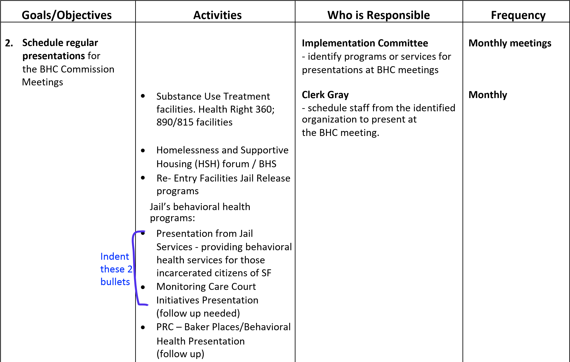
 | • | - Transgender community  impacted by trauma  - Lyric Youth Program  - Homeless Children’s Network  - Rafiki Coalition  - Dr. George Davis Senior Center  - DOR

Goals/Objectives | Activities | Who is Responsible | Frequency
3. Prepare 3 to 5 BHC Resolutions and  Commendations |  | Implementation Committee  - identify BHC-funded programs or individuals for recognition  (to receive a resolution or commendation) | Provide updates at  Monthly meetings  Need: Three (3)  Resolutions /  Commendations
3. Prepare 3 to 5 BHC Resolutions and  Commendations | More programs are needed:
3. Prepare 3 to 5 BHC Resolutions and  Commendations | - Friendship House  - Westside Crises Center  - Health Right 360  - Progress Foundation Avenues  - Homeless Children’s Network

Updated 10.31.2025; 01.28.2026
Prepared by BHC Clerk Gray/Commissioner Stevens

