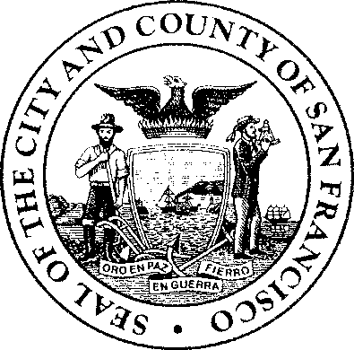
Elections Commission
City and County of San Francisco

Michelle Parker, President John Arntz, Director of Elections
Rebecca Bers Marisa Davis, Commission Secretary
Renita LiVolsi, Vice President
Trevor McNeil
Kelly Wong

REGULAR MEETING MINUTES – DRAFT
San Francisco Elections Commission Wednesday, April 16, 2025
6:00 p.m.
City Hall, Room 408
1 Dr. Carlton B. Goodlett Place San Francisco, California 94102 & Remote via WebEx

Order of Business

Call to Order & Roll Call
President Parker called the meeting to order at 6:06 PM.
Present: President Michelle Parker, Vice President Renita LiVolsi, Commissioner Trevor McNeil, Commissioner Kelly Wong.
Excused Absence: Commissioner Rebecca Bers
Also Present: Director of Elections John Arntz, Deputy City Attorney Ana Flores, and Commission Secretary Marisa Davis.

President Parker stated the Commission’s land acknowledgement of the Ramaytush Ohlone people.

President Parker also took a moment to thank resigned Commission Bernholz for her Commission service.

- General Public Comment (In Person)
Adonis (?) shared comments regarding a lack of diversity regarding political affiliation on the Commission.

Approval of previous meeting minutes
February meeting minutes were approved with President Parker after Commissioner feedback and edits (prior to the meting) had been forwarded to her.
Note: There are no March minutes as the meeting was cancelled.

There were no public commenters.

Director's Report
Director Arntz presented his March and April 2025 monthly report. Regarding the budget, the Mayor has not yet finalized the budget.

The Director’s report covered administrative functions and upcoming voter outreach activities, ongoing communication and efforts including language materials, newsletter, web page, Go Green, etc.

Commissioners had questions and concerns about the Trump Administration’s Executive Order issuing mandates regarding documentary proof of U.S. citizenship for voter registration in federal elections. Director Arntz told the Commission that This Order is currently facing legal challenge in 19 states. The U.S. House of Representatives passed the Safeguard American Voter Eligibility (SAVE) Act, The bill will next be considered by the U.S. Senate.

Public Comment (In Person)
(Name?) shared his comments regarding the SAVE ACT and encouraged the Commissioners to contact the Secretary of State. This commentor also stated his appreciation for the language and outreach updates.

Commissioners' Reports

President Parker informed the commissioners of potential SFEC meeting date changes due to commissioner being unavailable for the regularly scheduled May and June meetings. Since the Commission has two open positions, we are especially mindful of having a full quorum.

2023 and 2024 San Francisco Elections Commission Annual Report

A motion to approve the Election Commission 2023 and 2024 Annual Report was presented by Vice President LiVolsi and seconded by Commissioner McNeil.

The Commissioners voted as follows:

President Parker Yes
Commissioner Bers Excused Absence
Vice President LiVolsi Yes
Commission McNeil Yes
Commissioner Wong Yes

There were no public commenters.

Future Agenda Items

Racial Equity …

Meeting adjourned at 6:40 PM.

