

Civil Service Commission Annual Report

Annual Report
Fiscal Years 2020 – 2025
Covering the period July 1, 2020, through June 30, 2025

Email:Civilservice@sfgov.org  Website: www.sf.gov/civilservice |  | Tel: 628-652-1100  25 Van Ness Avenue, Suite 720  San Francisco, CA 941102
City and County of San Francisco
CIVIL SERVICE COMMISSION ANNUAL REPORT

FISCAL YEARS 2020 – 2025

Civil Service Commission

Kate Favetti, President (September 22, 2011 – Present)
Jacquline P. Minor, Vice President (August 5, 2019 – Present)
Vitus Leung, Commissioner (August 25, 2023 – Present)
Adam Wood, Commissioner (April 7, 2025 – Present)
Douglas S. Chan (July 22. 2013 – June 5, 2023)
F.X. Crowley, Commissioner (July 1, 2024 – February 3, 2025)
Elizabeth Salveson, Commissioner (March 5, 2018 – June 16, 2025)

Commission Staff

Sandra Eng, Executive Officer
Lavena Holmes, Assistant Executive Officer
Preeti S. Grewal, Senior Human Resources Analyst
Elizabeth Aldana, Human Resources Analyst
Lizzette Henríquez, Rules, Personnel & Office Coordinator
Shamika Gordon, Administrative Assistant
Luz Morganti, Senior Human Resources Analyst (Retired November 2024)

TABLE OF CONTENTS
I. Transmittal Letter to Mayor Lurie 4

II. Mission Statement 5

III. Vision statement 5

IV. Values statement 5

V. Overview of the Civil Service Commission 5

VI. Commission Staff 5

VII. Membership of the Commission 5

VIII. Civil Service Merit System 6

IX. Policy and Rules Making Authority 7

X. Policies and Procedures 7

XI. Civil Service Commission Rules 7

XII. Civil Service Commissioners Biographies 8-14

XIII. Civil Service Commission Organizational Chart 15

XIV. 125 Years of Past Civil Service Commissioners 16-17

XV. Past Civil Service Commission Executive Officers 18

XVI. Important Events that have Shaped the City and County of San Francisco Merit System 19-22
Continued page 4

XVII. Five Year Report 23
A. Commission Meeting 23
B. Election of Officers 25-26
C. Goals and Objectives 27
D. Civil Service Commission Rules Applicability 28
E. Civil Service Rule Amendments 29
F. Administrative and Public Records 30
G. Commission Policies and Procedures 30
H. Budget 31-33
I. Personal Services Contract 34-36
J. Hearing and Appeals 37
K. Appeals 37-38
L. Merit System Oversight Functions 39
M. Inspection Service Request 39-40
N. Merit System Audits 41
XVIII. Wage Setting Responsibilities of the Civil Service Commission 42
A. Settings of Salary and Benefits for Elected Officials and Members of the Board of Supervisors 42
B. Salary – Elected Officials 42
C. Salary – Members of the Board of Supervisors 42
D. Salary Adjustments 2020-2025 42-44
E. Benefits Setting for Elected Officials 44
F. Certification of Rates of Pay and Prevailing Wages 44
XIX. Employee Relations Ordinance Administration 46
A. Unfair Labor Practice Charges 46
B. Bargaining Unit Assignments 47
C. Management, Supervisory, Confidential and Designations 47
D. Recognition Elections: Employee Organization Certification or Decertification 47
XX. Affiliation, Disaffiliation or Merger of Labor Organizations 48

XXI. In Appreciation 48

TRANSMITTAL LETTER TO MAYOR DANIEL LURIE

January 26, 2026

The Honorable Daniel Lurie
Mayor of the City and County of San Francisco
City Hall, Room 200
1 Dr. Carlton B. Goodlett Place
San Francisco, CA 94102

Dear Mayor Lurie,

In recognition and celebration of 125 years of the Merit System oversight in the City and County of San Francisco, It is with great pride that the Civil Service Commission submits its 5-year Annual Report for the fiscal years beginning July 1, 2020, and concluding June 30, 2025. This report commemorates the Commission’s 125 continuous years of service in managing the Charter-mandated civil service merit system for public employment in the City and County of San Francisco.

The following report reflects the Commission’s overall commitment to and focus on providing fair and equitable opportunities for all prospective and current employees of the City and County. The quality of life in our great City is enhanced through the vital services provided by our City and County employees, and the Civil Service Commission strives to ensure an environment that is conducive to achieving the highest quality work ethic and job performance in carrying out the City’s mission.

Through our work managing salary administration for elected officials in San Francisco, we conduct the required salary surveys, as well as establish and adjust annually the salaries of elected officials and the Board of Supervisors in accordance with Charter mandates. Additionally, the Civil Service Commission certifies the highest prevailing wage rates, as presented by the Office of Labor and Standards Enforcement, for employees in the various crafts and kinds of labor occupations performing duties in private employment within the City and County of San Francisco. The prevailing wage (basic wage + fringe benefits) determination and the summary of local collective bargaining agreements are reviewed and certified by the Commission to support proposed changes in the prevailing wage rates to the Board of Supervisors for approval.

In addition to our work as a Commission, our staff and occasionally Commission President share historical context of the Commission through informational sessions, conducts merit system training and host learning for department HR staff, hiring managers and union business partners on merit system matters.

Current Priorities and Goals

With the continued support of the Department of Technology we are hopeful that we will be able to continue the digitization of historical records, move to a cloud based shared drive for Commission staff work product and develop an appeals database that will allow for the electronic filing of appeals and a data management center for greater efficiency. It is also our goal to fill the one vacancy on the commission to ensure a quorum for each meeting.

In closing, we would like to take this opportunity to recognize the outstanding performance of our very small, yet resilient, Civil Service Commission staff of six for their excellent work and continued dedication to ensure fairness in hiring and employment in the City and County of San Francisco. On behalf of the members of the Civil Service Commission and its staff, we are pleased to share with you the Commission’s Fiscal Years 2020 – 2025 Annual Report.

Respectfully submitted,
CIVIL SERVICE COMMISSION

Kate Favetti, Commission President and Sandra Eng, Executive Officer

II. Mission Statement

The Civil Service Commission safeguards the integrity and fairness of the merit (hiring and employment) system for the City and County of San Francisco, ensuring that employment practices are equitable, transparent, and compliant with the law. We serve as the policy and rule-making authority and final decision-maker on civil service matters, providing oversight and accountability for City and County of San Francisco, San Francisco Municipal Transportation Agency, and for matters involving non-certificated employees of the San Francisco Unified School District and the San Francisco Community College District.

Our mission is to:
- Promote continuous civil service reform by maintaining clear, consistent, and legally compliant rules, policies, and procedures that reflect current best practices and are accessible to all stakeholders.
- Ensure fairness and due process by hearing and ruling on appeals of the Human Resources Director and the Municipal Transportation Director related to merit system issues, employment restrictions, discrimination, harassment, retaliation, and serving as the final administrative remedy.
- Exercise fiscal and operational oversight by setting salaries and benefits for elected officials and approving the work scope of personal services contracts.
- Monitor and enforce compliance with civil service rules and policies across all covered entities.
- Evaluate system efficiency through regular review of key performance indicators to ensure the merit system remains robust, equitable, and effective.

Through these actions, the Commission upholds the principles of merit, accountability, and public trust in government employment.

V. Overview of the Civil Service Commission

The Commission is responsible for establishing, regulating, overseeing and serving as final arbiter of the City and County of San Francisco’s merit system. The Commission consists of five Commissioners appointed by the Mayor (with review by the Board of Supervisors) each serving a six-year term. The Charter requires the Commissioners to take an oath of office in opposition to civil service appointment as a reward for political activity. Commission meetings are generally held on the first and third Monday of each month (except holidays).
It is the goal of the Commission to provide fair treatment of applicants in all aspects of employment without regard to membership in a protected category and to prohibit nepotism or favoritism.

VI. Commission Staff

As a small department with six employees, each position’s duties and responsibilities are independently critical to carrying out the Commission’s mission. Department staff performs an outstanding job of diligently and tirelessly working together to ensure that the Commission able to achieve and surpass its performance measures for the fiscal year. They are to be commended for their continued excellent work and commitment to the merit system.

VII. Membership of the Commission

The Civil Service Commission is composed of five members, each appointed to serve a six-year term. The following Commissioners served on the Civil Service Commission during Fiscal Years 2020-2025. Currently four positions are filled, and one vacancy exists.

VIII. Civil Service Merit System

The Civil Service Commission was established by the electorate in 1900 in response to widespread corruption. With emphasis on merit principles, its aim was to eliminate the moral scourge of the “spoils system” in government employment. The City and County of San Francisco was the first public entity west of Chicago to establish a civil service system in the Freeholders Charter of 1900; and it remains one of the oldest merit systems in the country.

Under the Commission’s oversight, Civil Service, also known as the merit system, was created to ensure that the recruitment and retention of a qualified workforce, and the selection and promotion of employees providing public service and who are compensated by tax dollars, are conducted in a fair and impartial manner and in a competitive fashion.

The demand for accountability, high performance and ethical standards require a visible, objective public personnel process provided by a merit system. This demand for accountability is reflected in the Civil Service Commission Charter mandates to oversee the City’s merit system through the establishment of Rule, policies and procedures; hearing of appeals; inspection and audit services; training; and reports from the Executive Officer, Human Resources Director and Director of Transportation on the operation of the merit system.

As applied to classifications under the competitive civil service selection, appointment and removal procedures, the principles of the City and County’s merit system include:

1) Recruitment, employment, retention, and promotion of employees on the basis of qualifications and performance; and,
2) High performance and ethical standards, consistent with the employment of qualified individuals who successfully completed the examination process, were placed on an eligible list and completed the probationary period.

Further, it is the goal and policy of the Civil Service Commission to provide fair treatment of applicants in all aspects of employment without regard to sex or gender (including gender expression, identity orientation, and pregnancy status), race or ethnicity, age (if you’re over 40), religion, disability status or genetic information, medical condition, height or weight, political affiliation, marital or domestic partner status, prenatal status, and otherwise prohibited nepotism or favoritism.

The Commission assists in carrying out the mission of the City and County of San Francisco through a qualified, well-motivated workforce. Managers utilize hiring techniques that meet merit system principles and employees are hired based on merit and regular evaluation and performance appraisals in accordance with established standards. The Commission supports the immediate filling of a vacancy by an employee who meets or exceeds the minimum qualifications of the job and is hired permanent civil service with full benefits.

The ultimate goal of the Commission is to provide the framework of a strong, credible merit system resulting in a City and County workforce with intrinsic motivation to provide efficient service for the public.

IX. Policy and Rules Making Authority

The City and County of San Francisco Charter delineate the Civil Service Commission’s responsibilities and outlines civil service merit system requirements to include (but are not limited to):
The authority, purpose, definitions, administration and organization of the merit system and the Civil Service Commission.
The establishment of policies, procedures and Rules governing: allegations of discrimination or otherwise prohibited nepotism or favoritism; applications; examinations; eligibility; duration of eligible lists; certification of eligibles; leaves of absence; appointments; promotions; transfers; resignations; lay-offs or reduction in force, both permanent and temporary, due to lack of work or funds, retrenchment or completion of work; the designation and filling of positions, as exempt, temporary, provisional, part-time, seasonal, or permanent; status and status rights; probationary status and the administration of probationary periods except duration; pre-employment and fitness for duty medical examinations, except for the conditions under which referrals for fitness for duty medical examinations will be made, and the imposition of new requirements; classification; conflict of interest; and such other matters not in conflict with this Charter;

- The ability to inquire into the operation of the civil service merit system to ensure compliance; and,

- The hearing of appeals from an action of the Human Resources Director or the Director of the Municipal Transportation Agency or the Executive Officer.

X. Policies and Procedures

The availability of accessible services and the utilization of these services is a priority of the Civil Service Commission. The Commission has expanded upon the availability of information through knowledgeable staff, partnership with City departments and the Commission website (www.sf.gov/civilservice). Policy and procedures on “Appeals and Requests for Hearings” and “Submission of Written Reports on Appeals” are available online, along with the Commission’s recently adopted and/or revised policies.

XI. Civil Service Commission Rules

At the top of the Commission’s agenda is the need to continue to modernize and streamline the Civil Service Commission Rules, to protect the civil service merit system, and to mitigate risks which result from practices which may not be aligned with the efficient operation of a city department. The Civil Service Commission recognizes the need to increase the efficiency of our workforce by providing managers with the tools necessary to be agile and anticipate changes in the work environment so that they are able to adapt and respond to changes to eliminate duplicative or archaic practices. The Commission plans to issue a 2025 Rule Book in the Miscellaneous and MTA Service-Critical Volumes to replace the latest versions issued in 2000.

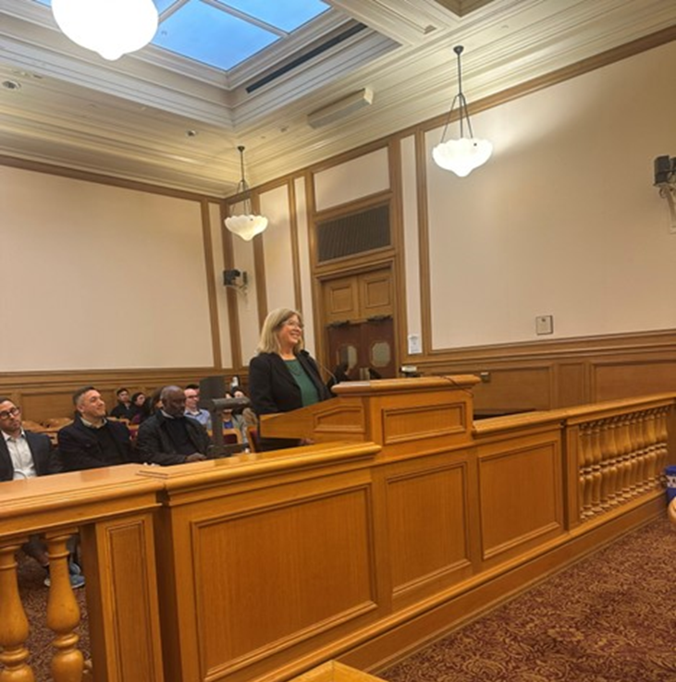

Commissioners biography

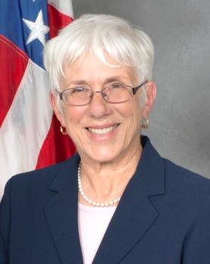
Kate Favetti, PRESIDENT
Appointed September 22, 2011, by Mayor Edwin Lee

As a City and County of San Francisco retiree with 36 years of dedicated service, the appointment of Commissioner Kate Favetti to the Civil Service Commission is hailed as an outstanding addition to the work and the betterment of the civil service merit system.

Commissioner Favetti’s City and County career encompassed progressively more complex positions in the professional, managerial and executive ranks culminating as a City Department Head for the Civil Service Commission. Her 36 years of work experience is a reflection of the civil service merit system at work, starting as a Clerk Typist, working her way to qualify and be appointed in the positions of Senior Clerk-Typist, Management Assistant, Personnel Analyst, Senior Personnel Analyst, Senior Departmental Personnel Officer, Human Resources Manager, Special Assistant, Assistant Executive Officer, Principal Employee Relations Representative, SFGH Human Resources Director, and ultimately as a City Department Head.

Commissioner Favetti is a well-known and respected facilitator of the City and County’s civil service personnel system. Her extensive knowledge of the legal framework of civil service and her considered judgment have established her as the key resource person to whom so many turn to for advice and information on personnel matters. Commissioner Favetti’s experience and achievements have earned her the honor and recognition of the International Public Management Association for Human Resources, IPMA-HR Executive Level Certification.

As a native and long-time resident of San Francisco, Commissioner Favetti is active in numerous neighborhoods, community service and non-profit organizations. She is President of the Westwood Park Homeowners Association; and a member of the OMI Cultural Participation Project, the Ocean Avenue Public Plaza Naming Committee, the Ocean Avenue Association Street Life Committee, the Phelan Loop Design Committee and the San Francisco Botanical Gardens.

Commissioner Favetti and her husband Ray are proud parents and doting grandparents. She is also a proud and regular transit rider of SF Muni.

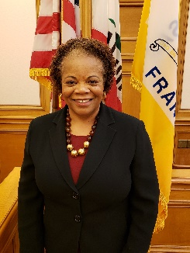
Jaqueline P. Minor, VICE PRESIDENT
Appointed August 5, 2019, by Mayor London N. Breed

Commissioner Minor is an accomplished lawyer. She retired as General Counsel for the Oakland School District in 2017, after eight (8) years of providing high quality legal advice and representation to the school district, senior management and elected school board. She was instrumental in supporting the development of major policy initiatives such as, the Voluntary Resolution Plan to end disproportionate suspensions of African American male students; successful resolution of litigation resulting from District police officer involved shooting; extensive day to day operational support to Fiscal, Human Resources, Facilities departments and the capital bond program; negotiation of agreements with charter schools resulting in capital improvements to District owned schools; and representation of the District in litigation of statewide significance.

Previously, she served as the Deputy City Attorney with the San Francisco City Attorney’s Office and as the Deputy City Attorney assigned to the San Francisco Unified School District. She also advised the San Francisco Public Utilities Commission on complex energy and environmental matters, which included representing the City in regulatory cases before the California Energy Commission and the California Public Utilities Commission. In addition, she represented the City in regulatory and civil litigation involving PG&E and advised the Sunshine Ordinance Task Force and the Human Rights Commission on municipal and policy issues.

Her professional experiences include Associate at Arnold & Porter Law Firm in Washington, DC and Assistant Vice President for business conduct standards (Ethics Officer), senior counsel and staff attorney for Pacific Bell Company in Los Angeles, San Diego and San Francisco, CA. She was selected to participate in Leadership America and to attend the Stanford University Graduate School of Business Executive Program. She is a magna cum laude graduate of Cedar Crest College in Allentown, PA and Georgetown University Law School. She is admitted to the bars in California, the District of Columbia and Virginia.
Commissioner Minor served as PTA President and sponsored a trip to Cuba for 25 San Francisco high school students. She and her family live in District 7. She is the proud grandmother of Riley who attends a Mandarin immersion preschool program in San Francisco.

“I am confident that Ms. Minor will serve our community well”, said London N. Breed, Mayor, City and County of San Francisco.

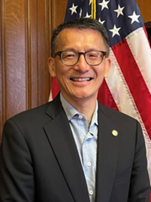
Vitus Leung, COMMISSIONER
Appointed August 25, 2023, by Mayor London Breed

Commissioner Vitus Leung has enjoyed an extensive career in human resources, primarily in traditional employee and labor relations, contract bargaining and organizational development & restructuring on behalf of public and non-profit employers.

He began his long-distinguished career as a union representative in San Francisco and during his 12-year tenure, earned the respect from union leadership, members, employer representatives, policy makers and elected/appointed officials as a collaborator, consensus builder and a “think outside of the box” problem solver. He negotiated a number of signature labor agreements, including an historic addendum labor agreement with the San Francisco Public Utilities Commission to seismically upgrade and repair the aging Hetch Hetchy Water System. He also helped navigate strategies to successfully effect policy changes and implement policy reforms to improve the lives and working conditions for their memberships.

Commissioner Leung later worked for the City and County of San Francisco in Human Resources serving as their Manager of Employee & Labor Relations and later as Director of Human Resources with the General Services Agency (GSA). There, he directed a team of HR professionals on workforce development, training and talent retention, employee and labor relations, worker’s compensation, employee safety and classification and compensation. He regularly served as chief negotiator for GSA and the City on complex labor contracts and was deployed to troubled city affiliates such as the San Francisco Housing Authority and the San Francisco Redevelopment Agency to restructure leadership teams to meet legal federal and local mandates.

From 2018 to 2024, he worked for a non-profit in San Francisco overseeing all business and operational activities and advising senior management team on workforce related issues, including but not limited to DEAI initiatives, complaints, grievances, unfair labor practice charges, public relations, and external political affairs.

Commissioner Leung has built his reputation on relationship and consensus building and he continues to serve as a mentor to other HR professionals in the Bay Area.

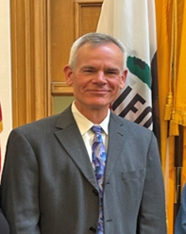
Adam Wood, COMMISSIONER

Appointed April 7, 2025, by Mayor Daniel Lurie

Commissioner Adam Wood retired from the San Francisco Fire Department in June 2024, after a 29-year career. During his time with the department, he was elected to the executive board of San Francisco Firefighters Local 798 in 2012, serving as director, vice-president, and completing his last term as secretary in January 2025. He was an elected delegate to the California Labor Federation from 2012 to 2025 and has served a member of the San Francisco Labor Council’s executive committee since 2021. He was appointed to the International Association of Firefighters (IAFF) standing Occupational Safety and Health Committee in 2021, representing the IAFF’s 10th District, including California, Arizona, New Mexico, and Hawaii. He joined the board of the San Francisco Firefighters Cancer Prevention Foundation in 2015 and continues to serve as the Foundation’s vice-president.

Commissioner Wood was born in Lewisburg, Pennsylvania, where his father taught at Bucknell University. His family moved to San Francisco in 1978, where Adam attended Grattan Elementary, Herbert Hoover Middle School, Lowell High School, City College of San Francisco, and San Francisco State University. He was a member of the Harvard University Trade Union Program’s 110th Class in 2023.

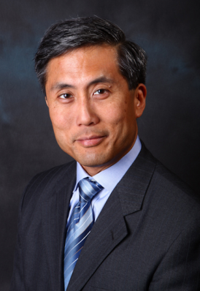
Douglas S. Chan, COMMISSIONER
Appointed July 22, 2013, by Mayor Edwin Lee

Douglas S. Chan is an attorney and a founding partner with the San Francisco law firm of CHAN & WELCH, LLP. his law practice is concentrated on transactions involving business formations, estate and asset protection planning, technology licensing, product distribution and supply arrangements, and strategic counseling for domestic and international companies. As a professional, he has received the highest (“a-v”) peer-review rating from the Martindale-Hubbell directory for two decades and named a Northern California “Super Lawyer” for business law.

Chan has held a variety of positions in public service. He is a former member of several other San Francisco commissions and boards. His previous experience includes service as a member of the Human Rights Commission from 2008 to 2013, Police Commissioner from 2004 to 2006, a member of the San Francisco Board of Permit Appeals from 1993 to 1995, two terms as a member of the Assessment Appeals Board from 1987 to 1993, and as a Commissioner on the San Francisco Rent Stabilization and Arbitration Board from 1983 to 1987. In 1992, Chan was also appointed to serve on the board of directors and chairman of the Mayor’s Chinatown Economic Development Group, Inc., a quasi-governmental, nonprofit corporation charged with promoting the economic recovery and development of the Chinatown community. In 2001, Governor Gray Davis appointed Chan to serve on the California Small Business Board, where he served until 2006.

Prior to his admission to the bar in 1981, Chan was a legislative aide to U.S. Senator Alan Cranston in Washington, D.C., advising on the Civil Service Reform Act of 1978, Postal Service reorganization, civil aviation deregulation, labor law reform legislation, federal procurement policies and practices, and product liability insurance reform. In 1984, he was the principal author of Asian Americans and the Presidency of the United States, the first nationally-circulated position paper on Asian American issues.

Prior to his service with the U.S. Senate, he worked for the San Francisco Human Rights Commission where he evaluated the effectiveness of the police community relations unit of the San Francisco Police Department and reported on the state of multicultural educational programs in the San Francisco Unified School District. A native San Franciscan, Chan’s civic participation in numerous business and community organizations spans three decades. He received his J.D. degree from the King Hall School of Law at the University of California, Davis, and he holds a bachelor's degree from Stanford University.

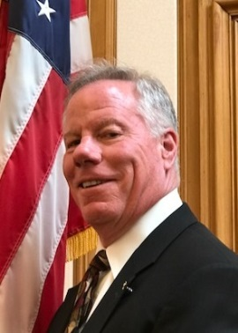
F. X. Crowley, COMMISSIONER (in memory)
Appointed December 5, 2016, by Mayor Edwin Lee

Posthumously, Commissioner Francis X. (F.X.) Crowley was a native San Franciscan, labor relations consultant, helping labor unions and business collaborate on resolving differences. He spent 30 years with the International Alliance of Theatrical Stage Employees (IATSE) Local 16 in San Francisco.

Commissioner Crowley began his career with IATSE as a stagehand in 1982 working in the San Francisco Opera and broadening his field experience in motion pictures and performing arts. He joined IATSE Local 16’s management staff in 1990. Commissioner Crowley was elected IATSE Local 16 president in 1994 and rose to Business Manager in 1997, where he was elected to seven consecutive terms, distinguishing himself as a highly-skilled labor negotiator and mediator. In 2013, Commissioner Crowley started his eponymous firm, the FX Crowley Company, providing consultation to organized labor, business and nonprofit organizations.

Commissioner Crowley served the City and County of San Francisco as Port Commissioner from 2010 to 2012 and as Public Utilities Commissioner from 2008 to 2010, where he also served as president from September 2009 through September 2010. He served the San Francisco Labor Council Executive Committee since 1994 and was a charter member of the Friends of the San Francisco Film Commission. Commissioner Crowley served three terms on the San Francisco Travel Board of Directors and was a member of the San Francisco-Cork Ireland Sister City Committee.

Commissioner Crowley received his Bachelor of Arts degree in Radio and Television from California State University, Long Beach in 1982. He is survived by his wife Nancy and four adult children.

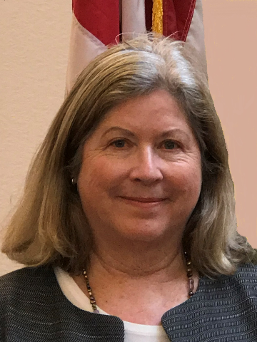
Elizabeth Salveson, VICE PRESIDENT
Appointed March 5, 2018, by Mayor Mark E. Farrell

Elizabeth Salveson served for 12 years as Chief Labor Attorney in the San Francisco City Attorney’s office (2004-2016), leading the team that represented the City on labor and employment issues, including civil service issues. She continued to serve the City with her appointment as a Civil Service Commissioner in 2018 until her term ended on June 30, 2025.

Prior to her appointment as Chief Labor Attorney, she was a Director for 20 years at the law firm Howard, Rice, Nemerovski, Canady, Falk & Rabkin in San Francisco (1984-2004), where she specialized in employment litigation and counseling. During her tenure with the firm, she served as Chair of the Employment Litigation & Counseling Group (1992-2004); Chair of the Litigation Department (1997-1999); and served terms on many other firm committees. She was an associate at the firm from 1978 until she became their Director.

During her professional career, Salveson taught Employment Discrimination (2007-2009) and Civil Pretrial Practice (1996-1998) at UC Hastings College of the Law. As an active member of the San Francisco legal community, she served on several boards, including the Board of Equal Rights Advocates (1994-2002), the Board of Governors of the Association of Business Trial Lawyers for Northern California (2008-2015), and the Board of Directors for the Bar Association of San Francisco (2003-2005). Salveson is an active member of the California Bar.

Salveson graduated with honors from UC Hastings College of the Law (1978). She received her B.A. degree from Occidental College.

Civil Service Commission Organizational Chart

xiv. 125 Years of past civil service Commissioners

Term of Service | Commissioner | Mayor
1900 – 1903 | P.H. McCarthy | James D. Phelan
1900 – 1902 | John R. Quinn | James D. Phelan
1900 – 1903 | J. Richard Freud | James D. Phelan
1902 – 1903 | Charles A. Murdock | James D. Phelan
1902 – 1905 | Lois J. Ohnimus | James D. Phelan
1902 – 1905 | John W. Rogers | E.E. Schmitz
1903 – 1904 | Charles J. Williams | James D. Phelan
1903 – 1906 | Joseph R.R. Mershore | E.E. Schmitz
05/20/1903 – 01/07/1912 | George H. Bahrs | E.E. Schmitz
1904 – 1906 | Charles J. Williams | E.E. Schmitz
1905 – 1908 | Edward F. Moran | E.E. Schmitz
1906 – 1910 | Richard Cornelius | E.E. Schmitz
1906 – 1909 | George H. Bahrs | E.E. Schmitz
1908 – 1910 | Matthew I. Brady | Edward R. Taylor
1910 – 1912 | Frank C. McDonald | P.H. McCarthy
01/31/1910 – 08/26/1910 | Charles M. Leavy | P.H. McCarthy
09/26/1910 – 01/07/1914 | Benjamin B. Rosenthal | P.H. McCarthy
1912 – 1913 | Harry E. Michael | P.H. McCarthy
1912 – 1918 | Earle A. Walcott | James Rolph, Jr
1913 – 1915 | Matthew I. Brady | James Rolph, Jr
1914 – 1917 | Benjamin B. Rosenthal | James Rolph, Jr
01/08/1915 – 01/04/1926 | John J. O'Toole | James Rolph, Jr
07/01/1917-12/18/1923 | George A. Tracey | James Rolph, Jr
1919 – 1931 | Earle A. Walcott | James Rolph, Jr
01/08/1924 – 06/30/1929 | John F. Davis | James Rolph, Jr
01/07/1926 – 01/27/1931 | Hugh McKevitt | James Rolph, Jr
1929 – 1935 | William P. McCabe | James Rolph, Jr
01/03/1931 – 06/30/1931 | Lewis F. Byington | James Rolph, Jr
01/27/1931 – 01/21/1941 | Howard M. McKinley | Angelo J. Rossi
1931 – 1937 | Lewis F. Byington | Angelo J. Rossi
1932 – 1949 | Harry K. Wolff | Angelo J. Rossi
1935 – 1947 | Milton S. Maxwell | Angelo J. Rossi
07/21/1941 – 04/16/1944 | John W. Bender | Angelo J. Rossi
04/1719/44 – 07/10/1947 | Allan E. Charles | Roger D. Lapham
1947 – 1953 | Francis P. Walsh | Roger D. Lapham
1947 – 1951 | John M. Kennedy | Roger D. Lapham
1949 – 1955 | Charles T. McDonough | Elmer E. Robinson
07/01/1951 – 11/14/1953 | John M. Kennedy | Elmer E. Robinson
11/16/1953 – 06/30/1960 | William Lahanier | Elmer E. Robinson
07/01/1953 – 09/30/1958 | Francis P. Walsh | Elmer E. Robinson
1955 – 1957 | John E. Hogg | Elmer E. Robinson
1957 – 1963 | William Kilpatrick | George Christopher
10/01/1958 – 10/23/1964 | Hubert J. Soher | George Christopher
1960 – 1967 | Richard C. Ham | George Christopher
1963 – 1969 | William Kilpatrick | John F. Shelley
10/23/1964 – 06/01/1966 | Dorothy Von Beroldingen | John F. Shelley
06/01/1966 – 06/30/1971 | Yori Wada | John F. Shelley
07/01/1967 – 11/17/1971 | John Molinari | John F. Shelley
07/01/1969 – 06/12/1972 | William Kilpatrick | Joseph L. Alioto
11/22/1971 – 06/15/1972 | Gary P. Vannelli | Joseph L. Alioto
1971 – 1977 | William J. Chow | Joseph L. Alioto
06/13/1972 – 06/30/1975 | Robert J. Costello | Joseph L. Alioto
06/15/1972 – 03/07/1979 | Joseph C. Tarantino | Joseph L. Alioto
07/01/1975 – 10/25/1975 | Robert J. Costello
10/25/1975 – 04/26/1979 | Frank N. Alioto | Joseph L. Alioto
12/05/1975-06/30/1981 | Darrell J. Salomon | Joseph L. Alioto
12/12/1975-06/30/1981 | Genevieve Powell | Joseph L. Alioto
07/01/1977-11/15/1977 | William J. Chow
11/15/1977-09/26/1978 | Lillian K. Sing | George R. Moscone
09/26/1978-09/10/1979 | Rolland C. Lowe | George R. Moscone
04/23/1979-01/04/1991 | Carlota Texidor del Portillo | Dianne Feinstein
04/26/1979-02/17/1982 | Allen Haile | Dianne Feinstein
09/11/1979-06/30/1989 | Louis Hop Lee | Dianne Feinstein
07/01/1981-03/29/1984 | Darrell J. Salomon | Dianne Feinstein
1981 – 1987 | Genevieve Powell | Dianne Feinstein
03/01/82-06/30/87 | Howard Gloyd | Dianne Feinstein
03/30/1984-06/30/1993 | A. Lee Munson | Dianne Feinstein
07/01/1987-01/29/1988 | Timothy L. Porter | Dianne Feinstein
07/01/1987-10/04/1993 | Cleo Donovan | Dianne Feinstein
10/25/1988-10/04/93 | Grant S. Mickins, III | Art Agnos
07/01/1989-09/11/1989 | Louis Hop Lee
11/06/1989-09/02/1990 | Richard J. Tomoda | Art Agnos
02/12/1991-10/11/1994 | Emi R. Uyehara | Art Agnos
02/12/1991-06/30/1997 | Juan Rios | Art Agnos
10/04/1993-06/30/1999 | Karen Clopton | Frank Jordan
10/04/1993-02/03/2000 | George Kosturos | Frank Jordan
07/01/1993-02/03/2000 | A. Lee Munson | Frank Jordan
10/08/1994-05/09/2003 | Adrienne G. Pon | Frank Jordan
07/01/1997-08/13/2003 | Rosabella Safont | Willie L. Brown, Jr.
1999 – 2005 | Morgan R. Gorrono | Willie L. Brown, Jr.
1999 – 2005 | Donald A. Casper | Willie L. Brown, Jr.
07/01/1999-10/01/2000 | Karen Clopton | Willie L. Brown, Jr.
03/09/2001-04/10/2001 | Johnnie Carter, Jr. | Willie L. Brown, Jr.
06/19/2001-09/03/2006 | Linda Richardson | Willie L. Brown, Jr.
05/10/2003-01/14/2008 | Thomas T. Ng | Willie L. Brown, Jr.
08/14/2003-06/02/2008 | Alicia D. Becerril | Willie L. Brown, Jr.
07/01/2005-08/30/2011 | Morgan R. Gorrono | Gavin Newsom
07/01/2005-08/14/2011 | Donald A. Casper | Gavin Newsom
02/15/2007-11/30/2008 | Yu-Yee Wu Sheridan | Gavin Newsom
01/15/2008-07/31/2013 | Mary Y. Jung | Gavin Newsom
09/19/2008-06/30/2015 | E. Dennis Normandy | Gavin Newsom
01/13/2009-01/22/2010 | Joy Y. Boatwright | Gavin Newsom
08/03/2010-08/30/2011 | Lisa Seitz Gruwell | Gavin Newsom
09/22/2011-Present | Kate Favetti | Ed Lee
01/04/2012-03/18/2019 | Scott R. Heldfond | Ed Lee
07/22/2013-06/30/2023 | Douglas S. Chan | Ed Lee
08/23/2013-12/31/2017 | Gina M. Roccanova | Ed Lee
12/05/2016-02/03/2025 | F.X. Crowley | Ed Lee
03/05/2018- 06/30/2025 | Elizabeth Salveson | Mark Farrell
07/19/2019-Present | Jacqueline Minor | London Breed
08/25/2023-Present | Vitus Leung | London Breed
04/07/2025-Present | Adam Wood | Daniel Lurie

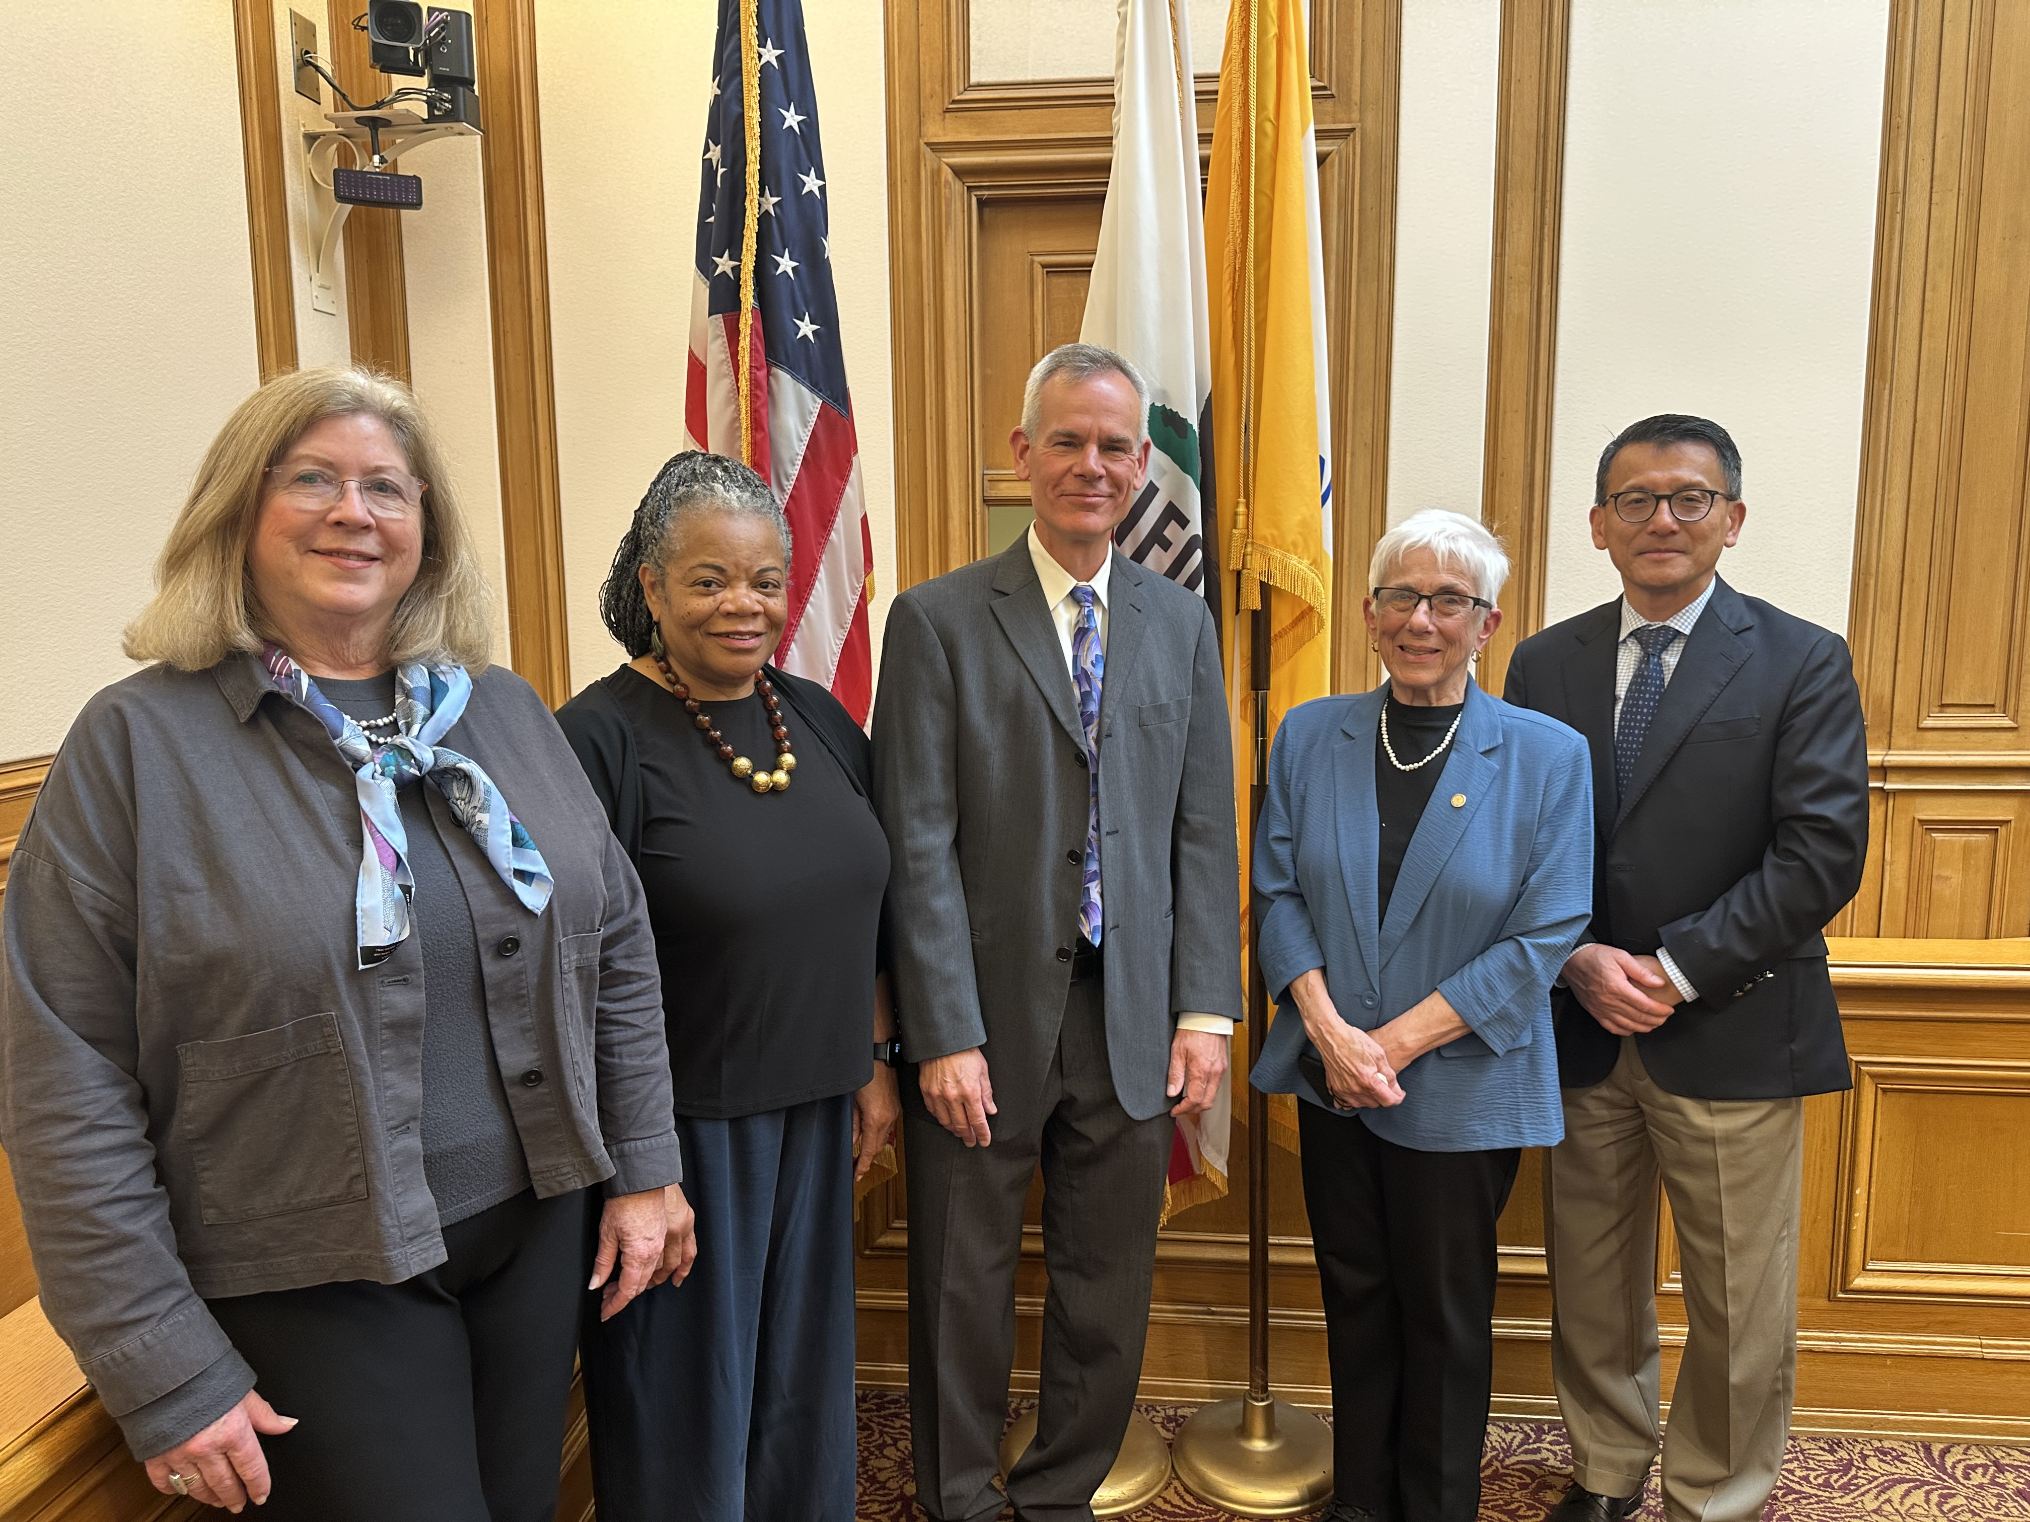

xv. PAST CIVIL SERVICE COMMISSION EXECUTIVE OFFICERS

GENERAL MANAGERS, EXECUTIVE OFFICERS, AND HUMAN RESOURCES DIRECTORS
OF THE CIVIL SERVICE COMMISSION AFTER THE PASSING OF PROPOSITION L IN 1993

1900 – PRESENT

NAME | APPOINTED | APPOINTMENT ENDED
Edward F. Moran | January 1, 1900 | December 18, 1905
Aarons H. Powers | December 18, 1905 | December 31, 1907
James J. Maher | January 13, 1908 | December 1, 1938
William L. Henderson | December 01, 1938 | June 9, 1943
Kathleen Dolen | June 9, 1943 | February 14, 1945
William L. Henderson | February 15, 1945 | September 04, 1958
Harry Albert (Acting) | September 11, 1958 | November 14, 1958
George Grubb | November 14, 1958 | December 14, 1971
Bernard A. Orsi | December 15, 1971 | March 01, 1977
James F. Wurm (Acting) | January 9, 1974 | June 6, 1974
James F. Wurm (Acting) | August 26, 1974 | January 7, 1975
John J. Walsh | March 03, 1977 | March 29, 1992
Albert C. Walker (Acting) | March 30, 1992 | April 18, 1993
Wendell L. Pryor | April 19, 1993 | December 5, 1995
 | EXECUTIVE OFFICERS
Albert C. Walker * | December 6, 1993 | January 1, 1998
Kate Favetti | March 16, 1998 | June 30, 2007
Anita Sanchez | July 1, 2007 | June 30, 2012
Jennifer Johnston | October 1, 2012 | September 26, 2014
Michael Brown | January 5, 2015 | November 1, 2019
Sandra Eng | May 18, 2020 | Present
 | HUMAN RESOURCES DIRECTORS
Wendell L. Pryor | April 19, 1993 | December 5, 1995
Andrea R. Gourdine | August 12, 1996 | May 15, 2004
Ted Yamasaki (Acting) | Don’t have these dates | October 8, 2004
Philip Ginsburg | October 09, 2004 | January 15, 2007
James Horan (Acting) | April 02, 2007 | October 08, 2007
Micki Callahan | October 09, 2007 | December 8, 2020
Carol Isen | March 25, 2021 | Present

NOTE: 2-5-1959: Position of Chief Examiner and Secretary retitled to General Manager, Personnel
* Proposition “L” (11/93) Restructured Personnel function and created a Department of Human Resources separate from the Civil Service Commission. Albert C. Walker was granted permanent civil service status to Executive Officer, Civil Service Commission by the terms of Proposition L (Charter Sec. 3.661). The Executive Officer position became appointive by the Civil Service Commission upon Mr. Walker’s vacating the position.

xvi. IMPORTANT EVENTS THAT HAVE SHAPED THE CITY AND COUNTY OF SAN FRANCISCO MERIT SYSTEM

The City’s existing merit system is the result of a series of reform movements. The electorate has recognized throughout its 125 years of existence that the merit system must change and adapt to meet contemporary demands.

1900 Establishment of the Civil Service Commission

The San Francisco Civil Service System was established under the 1900 Freeholder Charter.

- San Francisco Civil Service Commission was established, simultaneously, with the establishment of the merit system for the City and County of San Francisco
- The Civil Service Commission one of the oldest in the country, pre-dated (by just a few years) by Chicago, New York, and a few other Eastern municipalities. San Francisco has the oldest civil service system west of the Mississippi
- The first members of the Commission were P.H. McCarthy, John E. Quinn, and Richard Freud, who were appointed by Mayor James D. Phelan on December 30, 1899
- The Commission’s first meeting occurred on January 5, 1900; Richard Freud was elected president.
- The first competitive examination was held on January 8, 1900, and as a result, Edward F. Moran was appointed “Chief Examiner and Secretary” of the Commission
- The offices of the Commission opened to the public at noon, January 8, 1900, and by 5:00 p.m., 621 Laborers applications were received and hundreds of applications for examinations were issued
1932 Charter Reform

- Enlarged the scope of duties of the Civil Service Commission
- Gave greater powers to the Civil Service Commission to enforce its rulings and included the following important components:
- Control of the classification plan
- Restrictions on exempt appointments
- Provisions for practical, free and competitive examinations
- Persons appointed subject to a six-month probationary period
- Decision of Civil Service Commission on appeals is final
- Prohibition of political activity
- Central control to assure the unhampered operation of the merit system

1975 Expansion of Civil Service Commission

- Expanded the Civil Service Commission from three (3) members to five (5) members
- Required not less than one member be a woman
- Required a special oath upon appointment

1979 Compliance Agreement between the Office of Revenue Sharing and the City and County of San Francisco.
- Created open, competitive process for promotive examination
- Allowed horizontal and vertical access to the promotive system
- Permitted an accelerated examination process to address long-term temporary employees
- Expanded recruitment efforts for city jobs to support the citywide equal employment opportunity plan
- Established an in-house discrimination complaint procedure

1991 Civil Service Reform and Collective Bargaining

The electorate approved four (4) ballot measures that:
- Removed a number of Charter provisions word for word and added them to the Civil Service Commission Rules to allow for negotiation on changes through a meet and confer process
- Increased flexibility in classification of positions
- Established the minimum certification Rule of Three Scores
- Provided for collective bargaining subject to merit system carve-outs

1993 Creation of the Department of Human Resources
- Created the Department of Human Resources effective January 1, 1994
- Redefined the Civil Service Commission role from an operational personnel department to a policy making/appeals board

1996 Charter Revision
- The 1932 Charter was revised, re-codified and reorganized
- The role of the Civil Service Commission was clarified to reflect the Civil Service Commission’s jurisdiction and the merit system in the new collective bargaining environment
- Limits were placed in the Charter on the duration of provisional appointments
- Required that not less than two (2) members of the Civil Service Commission shall be women

1999 Creation of the Municipal Transportation Agency (Proposition E in November 1999)
- Created the Municipal Transportation Agency (MTA)
- Preserved the role of the Civil Service Commission as to merit system issues in the Municipal Transportation Agency

2001 Appeal to the Civil Service Commission of the Removal of the Director of Elections (Proposition E in November 2001)

- Amended the Department of Elections rules
- Provided that the Director of Elections is to be appointed by the Elections Commission from a list of qualified applicants according to the civil service provisions of the Charter
- Provided for the removal of the Director of Elections by the Elections Commission to be appealable to the Civil Service Commission

2002 Salary Setting – Board of Supervisors (Proposition J in November 2002)
- Amended Charter Section 2.100 to provide that the position of Member(s) of the Board of Supervisors is a full-time position and that the salaries be set by the Civil Service Commission once every five (5) years

2003 Ethics Reform (Proposition E in November 2003)

- Consolidated all of the City’s ethics laws into the Campaign and Governmental Conduct Code
- Created new laws and amended some of the existing laws including laws on hiring of family members and incompatible activities
- Provided that the Civil Service Commission shall provide commentary from a merit system perspective on Statements of Incompatible Activities forwarded by the Ethics Commission

2003 Early Retirement (Proposition F in November 2003)

- Provided Early Retirement, in that certain employees may become eligible to receive early retirement benefits which meant increasing an eligible employee’s age and credited service for both qualification and benefit computation purposes by three (3) years; however it was not applicable to disability or vesting benefits provisions or computations under Charter Sections A8.509(c), A8.509(f), A8.587-3 and A8.587-6

2006 Salary Setting – Elected Officials (Proposition C in November 2006)

- Amended Charter Section A8.409-1 to provide that the Civil Service Commission shall determine the base salaries every five (5) years of the Mayor, City Attorney, District Attorney, Public Defender, Assessor-Recorder, Treasurer and Sheriff, effective July 1, 2007

2007 Exempt Appointments in the Municipal Transportation Agency (MTA) (Proposition A in November 2007)

Allowed the MTA to create new managerial positions that are exempted from the civil service protection, subject to an overall limit of 2.75% of its workforce.

Proposition B (June 3, 2008) — Retiree Health Care Reform
- Created a Retiree Health Care Trust Fund to help pre-fund future retiree health benefits
- Required employees hired on or after January 10, 2009, to:
  - Work at least 5 years for the City to be eligible for retiree health benefits
  - Retire within 180 days of separation to maintain eligibility
  - Contribute 2% of their salary to the Retiree Health Care Trust Fund
  - Changed the vesting schedule for employer contributions

2010 Wages and benefits for Municipal Transportation Agency Transit Operators (Proposition G in November 2010)

- Eliminated the provision that the wages and benefits for MUNI transit operators would be established annually based on a survey conducted by the Civil Service Commission; instead, wages are to be determined through collective bargaining
- Eliminated the Charter-mandated trust fund (the general administration of which was established under the Civil Service Rules) created to receive and to administer the amount of money which represented the dollar value difference between benefits provided to MUNI transit operators under the Charter and those provided by the surveyed jurisdictions; instead, benefits are to be determined through collective bargaining
2010 Public Employee Pensions (Proposition D in June 2010)

- Proposition D (June 2010) - Public Employee Pensions: this measure, approved by voters, required new public employees to contribute 9% to their pension (compared to 7% for existing employees), mandated setting aside funds annually for future pension costs, and based pension payouts on earnings over the last two years of employment
2011 City Retirement and Health Care Benefits (Proposition C in November 2011)

- Proposition C (November 2011) - City Retirement and Health Care Benefits: This measure made significant changes to the pension and healthcare system, including:
- Increasing required employee contributions to both pension and health care
- Raising the age of eligibility for full pension benefits for most personnel (from 62 to 65) and firefighters/police officers (from 55 to 58)
- Altering the composition of the Health Services Board
- Requiring existing employees to contribute to a fund offsetting future health care costs
- Mandating that all elected officials participate in cost-sharing and pay their own retirement contributions
- Proposition B (November 2011) - Targeted Early Retirement: This measure aimed to encourage early retirement among older workers in job categories facing reductions, thus retaining younger workers who might otherwise face layoffs
2020 COVID-19 Pandemic
- During the COVID-19 Pandemic the Civil Service Commission learned to leverage available technology to provide all its services to employees and to the public remotely
- Implemented ability to conduct meetings remotely by using different platforms to hear appeals and request for Personal Services Contracts
- The Commission continues to conduct its hearings in hybrid format with participants and the public attending and providing public comment in person and remotely

2022 William B. Gould IV’s Report (CSC Meeting of December 5, 2022)
- Commission accepted the report of the findings and recommendations of Dr Gould’s report on the Review of City Equal Employment Opportunity Practices, Policies, and Procedures

2024 Nurses and 911 Operators Retirement Benefits Amendment (Proposition I November 2024)
- Proposition I (November 2024) - Nurses and 911 Operators Retirement Benefits Amendment: This measure, approved by voters, allows registered nurses and 911 dispatchers to enhance their retirement benefits by allowing per diem nurses to purchase credits towards their pension for prior work, and allowing 911 dispatchers, supervisors, and coordinators to increase pension benefits by joining the SFERS Miscellaneous Safety Plan



XVII. FIVE YEAR REPORT

This year’s Annual Report focuses on the accomplishments of the Civil Service Commission and its department during Fiscal Year 2020-2025 AND highlights the important role the Commission plays in creating a fair and equitable employment structure for the City and County of San Francisco.

A. - Commission Meetings
Regular Commission meetings are held on the first and third Mondays (except holidays) of each month in City Hall Hearing Room 400. Special meetings are called by the President or a majority of the Commission. All meetings of the Commission are open to the public except as otherwise legally authorized and/or required.

Commission meetings are conducted in accordance with the Commission’s Hearing Policies and Procedures, which are attached to each Agenda and Notice of Commission Meeting documents. The Hearing Policies and Procedures are also located on the Commission’s website at www.sf.gov/civilservice under “Policies and Procedures.”

Fiscal Year 2020-2021
- The Civil Service Commission convened a total of 21 Regular Meetings and 20 Special Meetings

Fiscal Year 2021 – 2022
- The Civil Service Commission convened 19 Regular Meetings and 1 Special Meeting

Fiscal Year 2022 – 2023
- The Civil Service Commission convened 17 Regular Meetings and 3 Special Meetings

Fiscal Year 2023 – 2024
- The Civil Service Commission convened 20 Regular Meetings and 2 Special Meetings

Fiscal Year 2024 – 2025
- The Civil Service Commission convened 20 Regular Meetings during Fiscal Year 2024-2025.



B. - Election of Officers

Fiscal Year 2020 – 2021 – Term ending on June 30, 2021
- Commissioner Elizabeth Salveson elected as President
- Commissioner Kate Favetti as vice President

Fiscal Year 2021 – 2022 – Term ending on June 30, 2022
- Commissioner Jacqueline P. Minor elected President
- Commissioner Kate Favetti as its Vice President

Fiscal Year 2022 – 2023 – Term ending on June 30, 2023
- Commissioners Jacqueline P. Minor re-elected as President
- Commissioner Kate Favetti re-elected as Vice President

Fiscal Year 2023 – 2024 – Term ending on June 30, 2024
- Commissioners Jacqueline P. Minor re-elected as President
- Commissioner Kate Favetti re-elected as Vice President

Fiscal Year 2024 – 2025 – Term ending on June 30, 2025
- Commissioner Kate Favetti re-elected President
- Commissioner Elizabeth Salveson elected Vice President

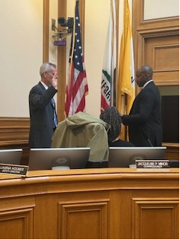

C. - Highlights of Fiscal Years 2020-2025
- Due to the COVID-19 pandemic, a shelter in place order was announced on March 16, 2020, for the City and County of San Francisco. Although employees who could perform their essential duties remotely were allowed to telecommute, most of the Civil Service Commission staff were unable to telecommute until May 2020. When Commission staff received equipment and technology to, gain access to Commission documents, and conduct virtual meetings, then they were able to work from home. Procedures were also changed to allow appellants to submit appeals by email.

- On March 17, 2020, the Mayor’s declaration temporarily waived the provisions of Civil Service Commission Rules and provisions of the Charter to expedite City hiring of permanent civil service employees (e.g. health care professionals) and to extend the duration of certain temporary exempt appoint types to ensure necessary City operations continuity in response to COVID-19.

- Policy bodies convened only virtually due to safety measures taken to prevent the spread of the COVID-19 disease.

- The 13th Supplemental Emergency Proclamation addressed emergency requests for Personal Service contracts related to COVID-19. These matters could be approved by the Executive Officer after consultation with the Commission President. The Executive Officer ensured departments notified unions with an explanation for the emergency approval of the personal service contract and the consequences if the personal service contract was not approved. When the Commission was able to meet virtually, departments were required to report back the status of the personal service contract to provide public transparency and an opportunity for public comment. Personal service contracts activated at the beginning of the Shelter in Place Order that did not receive prior Civil Service Commission approval were required to report back to the Civil Service Commission for public transparency.

- The Mayor’s 45th supplement to February 25, 2020, Emergency Declaration allowed policy bodies to return to meeting in person and remotely (hybrid). The first Civil Service Commission hybrid meeting (in room 400 at City Hall by Webex) was on March 7, 2022.

- On May 19, 2022, the Mayor issued the 48th Supplement to the Mayoral Emergency Declaration authorizing the Human Resources Director to temporarily modify Civil Service Commission Rules (with or without Commission approval) to establish a streamlined competitive examination process for employees who served for at least one year in a temporary exempt Category 18 position. This pilot program provided an opportunity for temporary- exempt Category 18 employees to transition to permanent civil service status utilizing methods other than the examination processes stated in the Rules. The Commission added the ability to appeal the examination process when they approved the expedited pilot program. The appeals submitted for these types of examinations drew attention to the rules provisions for exempt employees and identified a need to amend the rules so that future opportunities to transition from permanent exempt to permanent civil service did not exclude provisional and temporary exempt Category 16 and 17 employees. This process also identified for departments the need to plan in advance the filling of future positions.

- On February 28, 2023, the Mayor ended the COVID-19 public health emergency in San Francisco resulting in the return of general legal rules governing policy making bodies and the return of all Commissioners to their physical hearing rooms, as they were required to attend policy body meetings in-person.

- Commissioner Douglas S. Chan served the Commission for ten (10) years and attended his last Commission meeting on June 5, 2023.

- August 25, 2023, Vitus Leung was sworn in as a Commissioner for the Civil Service Commission.

- On December 4, 2023, the Commission adopted the amended Personal Service Contract Policies and Procedures to clarify the Commission’s oversight of the civil service merit system and personal service contract approval process while removing unnecessary confusion and delays in City contracting. This included increasing the Department of Human Resources authority to approve personal service contracts of $200,000 or less and no longer requiring certain types of contracts obtain Commission approval (e.g., contracts between City and government entities, legal mandates that require the use of non-City personnel, contracts for repair, maintenance, or similar services related to the purchase of software and equipment that must be performed by the manufacturer).

- Sadly, Commissioner F.X Crowley attended his last Commission meeting on January 6, 2025, approximately one month prior to his death, after having served the commission for nine (9) years.

- Commissioner Elizabeth Salveson served the Commission for seven (7) years and attended her last meeting on June 16, 2025.

- During the regular meeting of April 7, 2025, an historic document was presented to the office of Civil Service Commission. California State Assembly Rules Committee California Legislature Resolution (No.360) By Honorable Willie L. Brown, Jr., Eighteenth Assembly District Relative to the San Francisco Minority Police Recruitment Project signed by Leon Ralph, Chair and Leo T. McCarthy, Speaker of the Assembly and approved on August 27, 1974. This presentation posthumously honored Lieutenant Troy H. Dangerfield and his work on the project. Dangerfield family members and the SFPD Chief of Police and officers who worked alongside Lt. Dangerfield also attended the commission meeting presentation.

- On April 7, 2025, Adam Wood, retired San Francisco Fire Department personnel, was sworn in as a Commissioner for the Civil Service Commission.

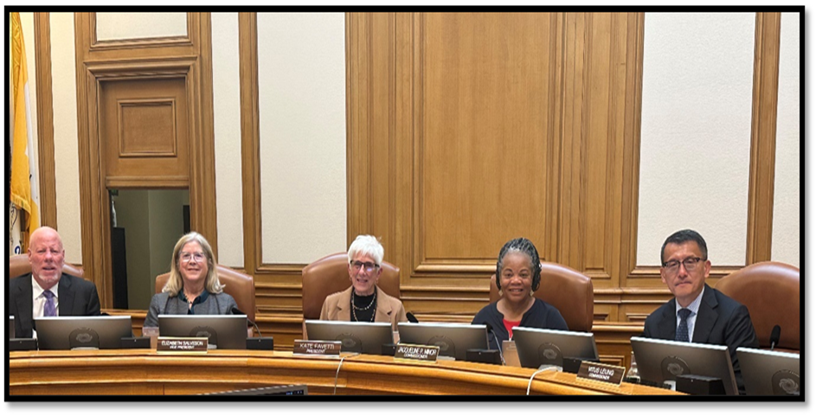

D. - Goals and Objectives
The Commission primarily focused its efforts on accomplishing specific deliverables and performance measures
with the purpose of 1) fulfilling the Commission’s legal and charter mandates; 2) supporting the Commission’s purpose and mission through its major program areas and functions; and 3) advancing the Commission’s objective to modernize and strengthen the operation of the City’s merit system.

- Increase the availability of information about the commission.

- Ensure that information on the commission’s website is intuitive and easily accessible.

- Increased the availability of information on the commission’s website.

- Ensure that commission staff and the commissioners have quick, efficient and easy access to the commission’s historical documents and files for proper record retention purposes and any specific research needs.

- Improve communication with appellants so that they may assess the civil service commission rules, policies and meeting procedures applicable to their appeal.

- Improve communication with departments so that they adhere to requirements for transparency and accurate information when requesting approval for professional and personal service contracts.

- Increase the use of technology and electronic communications with departments, appellants, labor unions and the public.

- Develop and present reports for the Commission describing deliverables and achievements on a timely basis.

- Ensure commission staff are committed to supporting the commission’s mission, goals and objectives.

- Ensure that the commission’s internal policies and administrative procedures are continuously updated and documented for commission staff.

- Resolve appeals in a timely manner by urging departments to submit staff reports on time and within established deadlines.

- Monitor appeal timelines and develop strategies to improve the efficiency by which appeals are resolved.

- Work collaboratively with department al representatives, the department of human resources and city attorney’s staff to establish new or amend current rules, policies and procedures to address changing needs, as appropriate.

- Review the civil service rule series and recommend revisions/deletions/addition aligned with developments in merit system employment practices.

E.- Civil Service Commission Rules Applicability
The Civil Service Commission acted on October 4, 1999, to recodify and reformat the Rules to provide consistent administration, uniformity and easy readability. Each volume of the Rules identifies the employee class(es) to which it applies.

Civil Service Commission Rules 1996 Edition |  | Civil Service Commission - Year 2000 Edition Rules
Rule Number and Title |  | Volume I Miscellaneous Classes | Volume II Uniformed Ranks of the SFPD | Volume III Uniformed Ranks of the SFFD | Volume IV MTA Service-Critical
Rule 1 | Authority and Purpose | Rule 101 | Rule 201 | Rule 301 | Rule 401
Rule 2 | Definitions | Rule 102 | Rule 202 | Rule 302 | Rule 402
Rule 3 | Equal Employment Opportunity | Rule 103 | Rule 203 | Rule 303 | Rule 403
Rule 4 | Administration | Rule 104 | Rule 204 | Rule 304 | Rule 404
Rule 5 | Meetings and Hearings of the Commission | Rule 105 | Rule 205 | Rule 305 | Rule 405
Rule 6 | TWU Trust Fund | Rule 106 | Blank | Blank | Rule 406
Rule 7 | Rules Related to the Employee Relations Ordinance | Rule 107 | Rule 207 | Rule 307 | Rule 407
Rule 8 | Blank | Blank | Blank | Blank | Blank
Rule 9 | Position Classification | Rule 109 | Rule 209 | Rule 309 | Rule 409
Rule 10 | Examination Announcements and Applicants | Rule 110 | Rule 210 | Rule 310 | Rule 410
Rule 11 | Examinations | Rule 111 | Rule 211 | Rule 311 | Rule 411
Rule 11A | Position Based Testing | Rule 111A | N/A | N/A | Rule 411A
Rule 12 | Eligible Lists | Rule 112 | Rule 212 | Rule 312 | Rule 412
Rule 13 | Certification of Eligibles | Rule 113 | Rule 213 | Rule 313 | Rule 413
Rule 14 | Appointments | Rule 114 | Rule 214 | Rule 314 | Rule 414
Rule 15 | Rules Related to the Employment of Persons with Disabilities | Rule 115 | Rule 215 | Rule 315 | Rule 415
Rule 16 | Medical Examinations | Rule 116 | Rule 216 | Rule 316 | Rule 416
Rule 17 | Probationary Period | Rule 117 | Rule 217 | Rule 317 | Rule 417
Rule 18 | Conflict of Interest | Rule 118 | Rule 218 | Rule 318 | Rule 418
Rule 19 | Resignation | Rule 119 | Rule 219 | Rule 319 | Rule 419
Rule 20 | Leaves of Absence | Rule 120 | Rule 220 | Rule 320 | Rule 420
Rule 21 | Layoff | Rule 121 | Rule 221 | Rule 321 | Rule 421
Rule 22 | Employee Separation Procedures | Rule 122 | Rule 222 | Rule 322 | Rule 422

F.- Civil Service Rule Amendments

Foremost in the Civil Service Commission’s agenda is to modernize and streamline the Civil Service Rules. Commission staff and DHR proposed several updates and changes to the Rules and the Commission’s policies and procedures over the past five fiscal years. The following Civil Service Commission Rules were adopted:

Fiscal Year 2020-2021
- Rule 411A Position Based Testing Program for the Service-Critical Classes of the Municipal Transportation Agency

- Rule 412 Eligible Lists Service-Critical Classes of the Municipal Transportation Agency

Fiscal Year 2021- 2022
- Rule 210 Police Examination Qualifications and Applicants

- Rule 111 Examinations

Fiscal Year 2022-2023
- Rule 411 Examinations for the Service-Critical Classes of the Municipal Transportation Agency

Fiscal Year 2023-2024
- Rules 02 Definitions, 05 Meetings and Hearings of the Commission, 010 Examinations Announcements and Applicants, 011 Examinations, 012 Eligible Lists, and 013 Certification of Eligibles were amended in all four volumes of the rules

- Rules 111A and 411A Position Based Testing Program were amended in volumes I and IV

Fiscal Year 2024-2025
- Rules 02 Definitions, 09 Position Classification and Related Rules, 013 Certification of Eligibles, 014 Appointments, 020 Leaves of Absence, and 021 Layoff were amended in all four volumes of the rules

- Rules 213 and 313 Certifications of Eligibles were amended in volumes II and III

- Rule 020 Leaves of Absence was amended in all four volumes of the rules

- Rules 02 Definitions, 011 Examinations, 012 Eligible Lists, and 013 Certification of Eligibles were amended in volumes I and IV of the rules

G.- Administrative and Public Records

During Fiscal Years 2020-2025, the department received nineteen (19) Public Records Request and four (4) Administrative Records Request.

Fiscal Year | Records Request | Administrative Records Request
2020-2021 | 1 | 0
2021-2022 | 3 | 3
2022-2023 | 6 | 1
2023-2024 | 6 | 0
2024-2025 | 3 | 0

H.- Commission Policies and Procedures

In its effort to address City department’s need for flexibility in personnel management, the Commission has an on-going process of seeking input from departments and responding to the needs requested of the City’s merit system. The Committee on Policy and Rules Revision (COPAR), made up of various departmental human resources managers Department of Human Resources representatives and Commission staff, convenes regularly to identify pain points, provide advice and address the operational impacts of the merit system. COPAR reviews, evaluates and makes recommendations on necessary Rule and policy changes. Commission Rules updates and modifications are evaluated to ensure compliance with federal, state and local laws.

Additionally, during this five-year review period the Commission working with the Human Resources Director and the Municipal Transportation Director made great strides toward Rule changes that support transparent and efficient hiring processes, based on merit and void of implicit and/or explicit bias. Commission staff also supports the Human Rights Commission by attending meetings and educating department equity leaders on best practices for hiring managers and departmental human resources staff to hire best-qualified candidates by utilizing merit system principles.


I.- Budget

Fiscal Year 2020-2021

The Department’s budget for FY 2020-21 was fully funded for six (6) FTE. Our approved overall budget for Fiscal Year 2020-2021 is 1.28 M. This FY, the Mayor requested further reductions for the next two (2) fiscal years. Therefore, we delayed filling the Deputy Director position and arranged to lease a smaller copier.

Account | Original Budget
Salary & Fringe Benefits
Salaries | $684,949
Temporary
Premium
Fringe Benefits | $309,025
Special and Professional Services
Non-Personnel Services | $32,795
Services of Other Dept. | $255,869
Materials, Supplies, Equipment  Expenditure Recovery | $3,395  $360,839
Total Budget | $1,286,033

Fiscal Year 2021-2022

The Department’s budget last fiscal year fully funded all six (6) FTE. Our approved overall budget for Fiscal Year 2021-2022 was 1.38 M.

Account | Original Budget
Salary & Fringe Benefits
Salaries | $766,580
Temporary
Premium
Fringe Benefits | $322,821
Special and Professional Services
Non-Personnel Services | $28,795
Services of Other Dept. | $266,721
Materials, Supplies, Equipment | $3,395
Expenditure Recovery  Total Budget | $360,839  $1,388,312

Fiscal Year 2022-2023

Our approved overall budget for Fiscal Year 2022-2023 was 1.44 M. This FY, we experienced $197K savings primarily in salaries and mandatory fringe benefits (84% utilization). The salary savings are primarily attributed to a vacancy and a leave of absence however those savings were offset by the adjustment of executive salaries that were not assumed in the budget going into the fiscal year.

Account | Original Budget
Salary & Fringe Benefits
Salaries | $821,941
Temporary
Premium
Fringe Benefits | $323,205
Special and Professional Services
Non-Personnel Services | $28,795
Services of Other Dept. | $270,029
Materials, Supplies, Equipment  Expenditure Recovery | $3,395  $360,839
Total Budget | $1,447,365

Fiscal Year 2023-2024
Our approved overall budget for Fiscal Year 2023-2024 (FY 2024) was 1.51 M. We experienced $131K savings the majority of which was in salaries and mandatory fringe benefits (85% utilization). These savings are primarily attributed to short-term leaves of absences and a premium pay correction in executive salaries that were not assumed in the budget going into the fiscal year.

Account | Original Budget
Salary & Fringe Benefits
Salaries | $902,920
Temporary
Premium
Fringe Benefits | $330,140
Special and Professional Services
Non-Personnel Services | $28,795
Services of Other Dept. | $246,359
Materials, Supplies, Equipment  Expenditure Recovery | $3,395  $430,839
Total Budget | $1,511,609

Fiscal Year 2024-2025

The Department is funded for six full-time equivalent (FTE) positions. Due to the brief vacancy of the 1244 Senior Human Resources Analyst position, we were able to achieve a small amount of salary savings in the budget for the fiscal year. However, the Mayor’s Office required 15% in ongoing reductions beginning in fiscal year 2025-26. Adjustments were made to the proposed budget reflecting the elimination of a single position to meet the Mayor’s directive. Fortunately, as the result of our efforts and the recognition of the department’s importance and small budget, the position identified for elimination was ultimately saved and the necessary upgrade for our 1426 clerk position, which has assumed additional fiscal and procurement duties was approved. An additional advantage that we were able to achieve without an increase in budget was direct support from the Department of Technology. With their direct support we have been able to receive laptops and docking stations to mobilize of workstations and we also implemented sharing meeting material with our commissioners through SharePoint to keep proprietary information secure.

Account | Original Budget
Salary & Fringe Benefits
Salaries | $918,248
Temporary
Premium
Fringe Benefits | $336,210
Special and Professional Services
Non-Personnel Services | $25,000
Services of Other Dept. | $242,144
Materials, Supplies, Equipment  Expenditure Recovery | $3,055  $430,839
Total Budget | $1,524,657

J.- Personal Services Contract

The following charts provide a breakdown of the number of services that departments requested to contracted out under Civil Service Commission PSCs reviewed over five fiscal years:

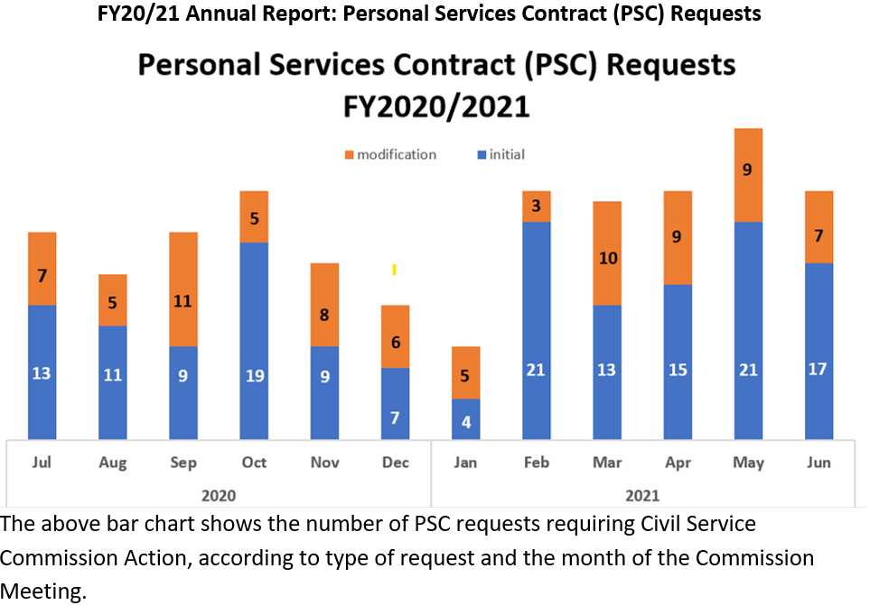

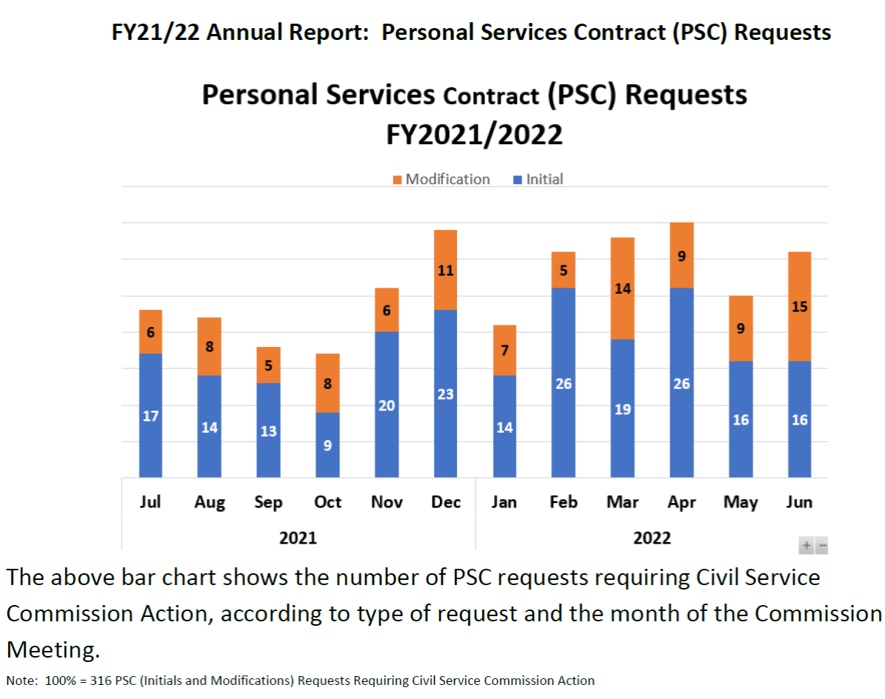
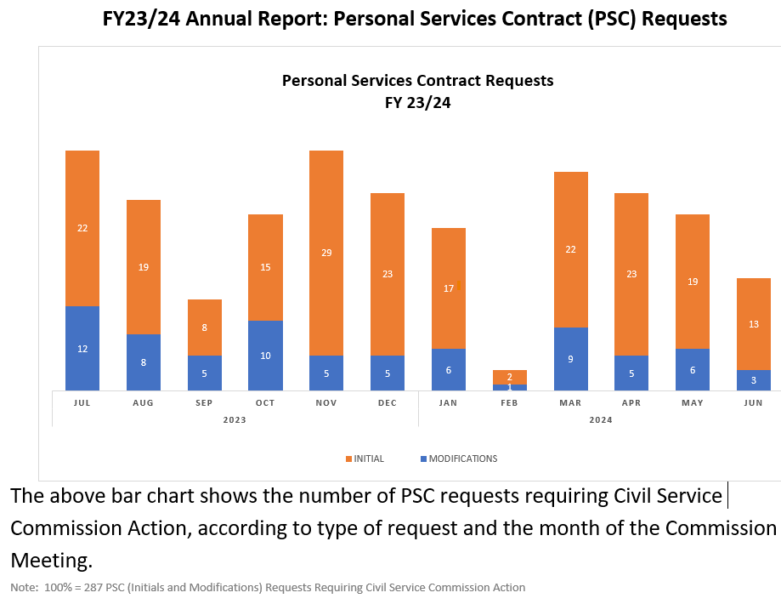

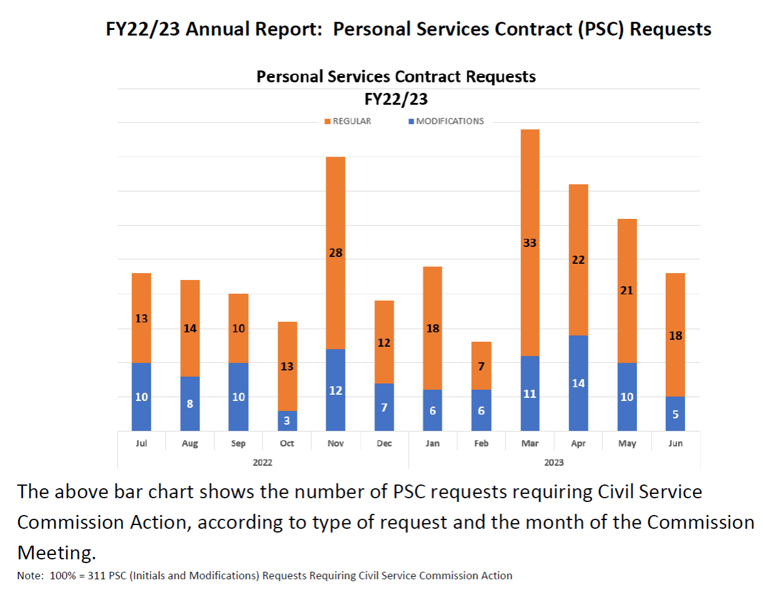



K.- Hearings and Appeals

Hearing of Appeals on the Merit System

One of the Commission’s most important Charter-mandated functions is to consider appeals on the merit system and other matters within its jurisdiction. Appeal hearings provide a mechanism for the Commission to monitor and oversee the operation of the merit system and ensure compliance with merit system principles and the Civil Service Rules.

The Commission presides over hearings covering a range of merit system issues, including appeals of future employment restrictions placed on employees after separation from service, examination appeals, classification appeals, certain compensation appeals, and appeals of the Human Resources Director’s decisions on certain administrative matters. The Commission also hears appeals of decisions of the Director of Transportation on merit system matters affecting service-critical classes at the Municipal Transportation Agency.

L.- Appeals

Fiscal Year 2020-2021

The Commission received a total of 47 new appeals and requests for hearings in Fiscal Year 2020-2021, in addition to the 47 active unresolved appeals that were carried over from the previous fiscal year of 2019-20. The Commission heard and resolved 41 of the 94 pending appeals in Fiscal Year 2020-21, representing 44%, which falls below our target goal of 70%

Fiscal year 2021-2022

The Commission received a total of 42 new appeals and requests for hearings in Fiscal Year 2021-2022, in addition to the 47 active unresolved appeals that were carried over from the previous fiscal year. The Commission heard and resolved 44 of the 89 pending appeals last fiscal year, representing 49%, which falls below our target goal of 70%.

Fiscal year 2022-2023

The Commission received a total of 96 new appeals and requests for hearings in Fiscal Year 2022-2023, in addition to the 46 active unresolved appeals that were carried over from the previous fiscal year. This is a 129% increase compared to new appeals received in FY2022. The Commission heard and resolved 97 of the 142 pending appeals last fiscal year, representing 68%. Although we did not reach our performance measure goal of resolving 70%,

Fiscal year 2023-2024

The Commission received a total of 71 new appeals and requests for hearings in Fiscal Year 2023-2024, in addition to the 44 active unresolved appeals that were carried over from the previous fiscal year. The Commission heard and resolved 73 of the 115 pending appeals last fiscal year, representing 63%. The Commission did not reach the performance measure goal of resolving 70%.

Fiscal Year 2024-2025

The Commission received a total of 79 new appeals and requests for hearings in Fiscal Year 2024-2025, in addition to the 37 active unresolved appeals that were carried over from the previous fiscal year. This is a 10% increase in appeals submitted to the Commission. (Attachment B)

The Commission resolved 27 of the 36 examination appeals representing 75%. The Commission passed the performance measure goal of resolving 60% of the examination appeals within 60 days.

The Commission heard and/or resolved 18 of the 39 equal employment opportunity appeals
representing 46%. The Commission did not reach the performance measure goal of resolving
60% of the equal employment opportunity appeals, due to litigation, grievances, arbitration, settlement agreements, and DHR EEO requests for further investigations. The Commission heard or resolved 14 of the 36 requests for hearing on future employment restrictions representing 48%. The Commission did not reach the performance measure goal of resolving 60% of the requests for hearing on future employment restrictions due to litigation, grievances, arbitration or pending settlement agreements.

The Commission heard and/or resolved 5 of the 5 appeals regarding other matters representing 100%. The Commission passed the performance measure goal of resolving 60% of appeals regarding other matters.

M.- Merit System Oversight Functions

The Inspection Service is another important and effective mechanism under the Charter by which the Civil Service Commission ensures compliance with the Civil Service Rules and Commission policies. Commission staff investigates as Inspection Service requests those merit system complaints, questions and concerns it receives which are not otherwise subject to protest or appeal under Civil Service Rules. The Civil Service Commission is further authorized under the Charter to inquire into the conduct of any department or office of the City and County; and may hold hearings, subpoena witnesses, administer oaths, and compel the production of books, paper, testimony and other evidence in pursuing such inquiry.

All departments are required to cooperate with the Civil Service Commission and its staff in any inquiry or investigation. The Commission’s investigations may include a review or audit of departmental records and merit system practices, and interviews with witnesses or department representatives. In all instances where there is a finding of a merit system violation, Commission staff works with departments to correct practices or actions that are found to violate merit system principles; findings of significant merit system violations are scheduled for hearing before the Civil Service Commission so that an appropriate remedial action may be ordered.

Any individual or entity may request that the Commission undertake an Inspection Service review into a merit system matter.



N.- Inspection Service Request

Fiscal Year 2020-2021

The Commission received a total of 47 new appeals and requests for hearings in Fiscal Year 2020-2021, in addition to the 47 active unresolved appeals that were carried over from the previous fiscal year of 2019-20. The Commission heard and resolved 41 of the 94 pending appeals in Fiscal Year 2020-21, representing 44%, which falls below our target goal of 70%.

Fiscal Year 2021-2022

In Fiscal Year 2021-2022, the Commission received a total of 55 Inspection Service Requests from employees, labor representatives, job applicants/candidates, anonymous individuals, and members of the public. (Attachment C). Due to the Shelter Order, many department offices remained closed unless they were providing essential public services; therefore, many inspection service requests could not be resolved within 60 days. The Commission resolved 22% (12 out of 55) of the Inspection Service Requests within 60 days, which is below our target of 80%.

Fiscal Year 2022-2023

In Fiscal Year 2022-2023, the Commission received a total of 65 Inspection Service Requests from employees, labor representatives, job applicants/candidates, anonymous individuals, and members of the public. (Attachment C). During the ongoing COVID pandemic many department offices maintained minimal staffing and experienced organizational changes; therefore, many inspection service requests were not resolved within 60 days. The Commission resolved 54% (35 out of 65) of the Inspection Service Requests within 60 days, which is below our target of 80%.

Fiscal Year 2023-2024

Fiscal Year 2023-2024, the Commission received a total of 90 Inspection Service Requests from employees, labor representatives, job applicants/candidates, anonymous individuals, and members of the public. (Attachment C). Commission staff resolved 60% (54 out of 90) of the Inspection Service Requests within 60 days, which is below our target of 80%.

Fiscal Year 2024-2025

In Fiscal Year 2024-2025, the Commission received a total of 112 Inspection Service Requests from employees, labor representatives, job applicants/candidates, anonymous individuals, and members of the public. (Attachment C). Commission staff resolved 76% (86 out of 112) of the Inspection Service Requests within 60 days, which surpassed our goal of 70%. Commission staff resolved the total number of 92 out of 112 (82%) inspection service requests. The Commission staff surpassed the goal of completing 70% of inspection service requests. Please note that 31 (28%) of the inspection service requests were received in the last 2 months of the fiscal year. In Fiscal Year 2024-2025, staff found that complaints included favoritism, nepotism, appointees not meeting the minimum qualifications, order of layoff, probationary periods, reversion rights, out-of-class assignments, status grant, disqualification after appointment to the position, leaves of absence, and employee personnel files. The following chart summarizes the reviews.

O.- Merit System Audits

The Commission formally established the Merit System Audit Program in 2006 as another mechanism to carry out its merit system oversight functions, with the goal of ensuring that City departments are adhering to Federal and California State law, the Civil Service Rules, and Commission policies and procedures. The audits are conducted in the same manner as Inspection Service reviews. The topics of the pre-planned audits are determined each fiscal year as part of the process by which the Civil Service Commission sets its annual goals and objectives.

The Commission’s Audit Program for Fiscal Years 2021-2025 audit reviews focused on reviewing nine recruitments conducted by various City departments to assess the department’s compliance with Rules and procedures specific to their Departmental practices regarding the verification and documentation of minimum qualifications for individuals appointed to Permanent Civil Service (PCS), Permanent Exempt (PEX) or Temporary Exempt (TEX) positions.

Merit Audit Report FY 2020-21:

Of the six (6) departments that participated in this audit, five (5) complied with the procedure, demonstrating that each appointee was qualified for the position to which they were appointed. One department, the Department of Building Inspection, failed to obtain verification of external work experience for an employee who was appointed to Class 6248 at the time of hire on January 11, 2016.

Merit Audit Report FY 2021-22:

All three (3) departments that participated in this audit complied with the procedure, demonstrating that each appointee was qualified for the position to which they were appointed.

Merit Audit Report FY 2022-23:

All five (5) departments that participated in this audit complied with the procedure, demonstrating that each appointee was qualified for the position to which they were appointed.

Merit Audit Report FY 2023-24:

Of the nine (9) departments that were audited for compliance of obtaining verification of qualifying education and experience, for the appointees selected to fill Temporary Exempt or Permanent Exempt management positions, eight (8) departments provided documentation verifying the qualifications of each of their appointees. One (1) (Mayor’s Office) department did not possess the documents verifying the appointee’s education or qualifying work experience for a class 0953 Deputy Director III – Permanent Exempt (PEX) status position.

Merit Audit Report FY 2024-25:

The number of audits increased to thirteen (13) for FY 2024-25. This audit focused on reviewing the selection and appointment practices for thirteen (13) management recruitments conducted by City departments. Of the ten (10) departments audited for compliance in verifying the qualifying education and experience of appointees selected for Permanent Civil Service or Permanent Exempt management positions, nine (9) departments provided documentation verifying their appointees’ qualifications, one (1) (San Francisco Art Commission) department submitted the verification for class O951 Deputy Director during the audit to validate the appointment which was effective August 31. 2024.

Findings of the audit program:
Overall, our reviews assessed that there was compliance with Charter provisions, Commission Rules, and merit system policies and processes.

XVIII.- WAGE SETTING RESPONSIBILITIES OF THE CIVIL SERVICE COMMISSION

A.- Setting of Salary and Benefits for Elected Officials and Members of the Board of Supervisors

The Commission sets the salary and benefits of all elected officials of the City and County of San Francisco in accordance with the Charter Section A8.409-1 and Section 2.100.

B.- Salary - Elected Officials

On November 7, 2006, the City and County of San Francisco’s Electorate approved Proposition C, amending City Charter Section A8.409-1 - Employees Covered. The Charter amendment requires that the Civil Service Commission set the base salary of the Mayor, City Attorney, District Attorney, Public Defender, Assessor-Recorder, Treasurer, and Sheriff once every five years by averaging the salaries of the comparable elected officials in Alameda, Contra Costa, Marin, San Mateo, and Santa Clara counties. For each year between the five-year cycles, the Civil Service Commission is required to adjust the salaries to reflect the upward movement in the CPI during the prior calendar year not to exceed five percent. The Charter prohibits the Commission from reducing the salaries of each elected official in setting the base five-year salary. If the City and employee organizations agree to amend the compensation provisions of an existing memorandum of understanding to reduce costs, the Civil Service Commission is required to review and amend the salaries of the above-named elected officials.

C.- Salary - Members of the Board of Supervisors

On November 5, 2002, the City and County of San Francisco Electorate approved Proposition J, amending City Charter Section 2.100 - Composition and Salary to provide that Member of the Board of Supervisors is a full-time position. As amended, the Charter also now requires the Civil Service Commission to: 1) establish a five-year salary cycle; 2) consider a salary survey of California cities and counties with full-time City Councils and County Supervisors; 3) transmit its salary determination to the Controller in a timely manner to coordinate with City budget processes and related procedures; and 4) set the salary of the Board of Supervisors once every five years.
Charter Section 2.100. directs the Civil Service Commission to set the salary for the City and County of San Francisco Board of Supervisors’ once every five (5) years. Before the Commission determines the Supervisors’ salary, the Charter requires that the Civil Service Commission conduct and consider a salary survey of other full-time City Councils and County Boards of Supervisors; and to transmit its salary determination to the Controller in a timely manner so that funds can be set aside to ensure implementation.

Commission staff surveyed data for all 58 California counties and all 482 California cities to determine which counties and cities were comprised of full-time Board of Supervisors and/or City Council members.

Commission staff presented to Commissioners a report on:
- Salary Adjustments 2020: Elected Officials and Members of the Board of Supervisors

May 18, 2020, report was delayed to November 16, 2020, the Commission approved the salary adjustments for Elected Officials (4th year of 5 – year cycle) and the Board of Supervisors (2nd year of 5 – year cycle) aligned with the CPI-U of 3.5% increase salary effective December 26, 2020, for the Fiscal Year 2020-2021 budget.

- Salary Adjustments 2021: Elected Officials and Members of the Board of Supervisors

May 3, 2021, the Commission approved the salary adjustments for Elected Officials (5th year of 5-year cycle) and the Board of Supervisors (3rd year of 5-year cycle) aligned with the CPI-U of 1.7%, increase salary effective July 1, 2021, for the Fiscal Year 2021-2022 budget.

- Salary Adjustment 2022: Members of the Board of Supervisors

May 16, 2022, the Commission approved and certified the annual adjustment of the (4th) Year of the 5-Year Cycle of Salary of Members of the Board of Supervisors, for the FY 2022-23 budget. The Commission approved the proposed salary adjustment Salary Setting for the City and County of San Francisco Board of Supervisors for a Five (5) Year Cycle, effective July 1, 2024, through June 30, 2029, in Accordance with Charter Section 2.100, will be increased by 4.2%, which shall be $170,433 effective July 1, 2024. Subsequent years provide an adjustment according to the CPI-U at a cap of 5% in a given year; if CPI-U is below 0 there will be no change in salary.

- Salary Adjustment 2022 through 2027: Elected Officials

The Commission certified the base salary for Elected Officials for the five (5) year cycle effective July 1, 2022, through June 30, 2027, in Accordance with Charter Section A8.409-1. Increases were granted to elected officials with the exception of City Attorney, Mayor and Public Defender positions. Subsequent years provide an adjustment according to the CPI-U at a cap of 5% in a given year; if CPI-U is below 0 there will be no change in salary.

- Salary Adjustments 2023: Elected Officials and Members of the Board of Supervisors

May 15, 2023, the Commission approved the proposed salary adjustment for the (5th) Year of the 5-Year Cycle of Salary of Members, Board of Supervisors, and the (2nd) Year of the 5-Year Cycle of Salary for Elected Officials, with a 4.75% increase effective July 1, 2023, for Fiscal Year 2023-24.

- Salary Adjustments 2024: Elected Officials

June 3, 2024, the Commission approved the proposed salary adjustment (3rd) Year of 5-Year Cycle of Salary for Elected Officials on the CPI-U increase of 2.6% for Fiscal Year 2024-25.

Date | Decision | Charter Section | Basis | Effective Date | Fiscal Year
3-Jun-24 | Approved salary adjustment (3rd year of 5-year cycle for Elected Officials) | Sec A8.409-1 | CPI-U 2.6% | FY 2024-25 | 2024-2025

- Salary Adjustments 2024 through 2029: Members of the Board of Supervisors

June 17, 2024, the Commission approved the proposed salary adjustment Salary Setting for the City and County of San Francisco Board of Supervisors for a Five (5) Year Cycle, effective July 1, 2024, through June 30, 2029, in Accordance with Charter Section 2.100, will be increased by 4%, which shall be $170,433 effective July 1, 2024. Subsequent years provide an adjustment according to the CPI-U at a cap of 5% in a given year; if CPI-U is below 0 there will be no change in salary.

Date | Decision | Charter Section | Basis | Effective Date | Fiscal Year
17-Jun-24 | Approved salary adjustment for Supervisors (5-year cycle, effective July 1, 2024 - June 30, 2029) | Sec 2.100 | 4% increase; subsequent years CPI-U up to 5% cap | 1-Jul-24 | 2024-2029

- Salary Adjustments 2025 through 2026: Elected Officials and Members of the Board of Supervisors

June 2, 2025, the Commission approved the proposed salary adjustment (4th) Year of 5-Year Cycle of Salary for Elected Officials (2nd) Year of 5-Year Cycle of Salary for Board effective July 1, 2025, for Fiscal Year 2025-2026 based on the CPI-U increase of 2.9%; for Fiscal Year 2025-26.

Date | Decision | Charter Section | Basis | Effective Date | Fiscal Year
2-Jun-25 | Approved salary adjustment (4th year of 5-year cycle for Elected Officials) and (2nd year of 5-year cycle for Supervisors) | Sec A8.409-1, Sec 2.100 | CPI-U 2.9% | 1-Jul-25 | 2025-2026

E.- Benefit Setting for Elected Officials
The Civil Service Commission also continues to set the benefits of elected officials (the above-listed elected officials and Members of the Board of Supervisors) to take effect July 1st of each year in accordance with Charter Section A8.409-1, which provides that the benefits of elected officials may equal but may not exceed those benefits provided to any classification of miscellaneous officers and employees at the same level of benefits as those provided to covered employees of the Municipal Executive’s Association (MEA).

F.- Certification of Rates of Pay and Prevailing Wages
The Charter mandates that the Commission certify the rates of pay for Police Officers, Firefighters, Registered Nurses, and the prevailing rate of wages of the various crafts and kinds of labor as paid in private employment in the City and County of San Francisco. The attached General Prevailing Wage Determinations made by the Director of the California Department of Industrial Relations (DIR) pursuant to the California Labor Code reports the highest prevailing rate of wages of the various crafts paid in private employment in the City and County of San Francisco for: 1) workers performing work under City contracts for public works and improvement; 2) workers performing work under City contracts for janitorial services; 3) workers performing work in public off-street parking lots, garages, or storage facilities for automobiles on property owned or leased by the City; 4) workers engaged in theatrical or technical services for shows on property owned by the City; 5) workers performing moving services under City contracts at facilities owned or leased by the City; and 6) workers engaged in the hauling of solid waste generated by the City in the course of City operations, pursuant to a contract with the City.

2020 → 2021
Prevailing wage increases between 2020 and 2021 averaged around 2.5%, reflecting the first cost-of-living adjustments under renewed labor contracts for several trades.

2021 → 2022
Prevailing wages rose by approximately 2.8%, continuing the gradual upward trend. Many classifications — including Iron Workers, Janitorial Services (SEIU Local 87), and Motorbus Contracts (Teamsters 665) reflected the start of multi-year escalators in their collective bargaining agreements.

2022 → 2023
Prevailing wages rose by approximately increased by an average of 3%, as newer collective bargaining agreements took effect. Notable gains were recorded in Trade Show & Special Event Work (IUPAT Local 510) and Solid Waste Haulers (Teamsters Local 350), both implementing structured step-ups and benefit enhancements.

2023 → 2024
Prevailing wage rates rose by roughly 3.2% citywide. The year was characterized by stability and alignment with scheduled CBA escalations under long-term agreements extending through 2025 and 2026
Employee Relations Ordinance Administration.

2024 → 2025
Prevailing wage increases between 2024 and 2025 averaged around 3%, consistent with inflationary adjustments and collective bargaining agreements negotiated by Teamsters Local 350, Teamsters Local 853, SEIU-USWW, and other unions covering janitorial, hauling, and transportation classifications.

XIX.- EMPLOYEE RELATIONS ORDINANCE ADMINISTRATION
The Employee Relations Ordinance (ERO) was established in 1973 to promote employee-employer relations and to recognize the right of City and County employees to join employee organizations of their own choice and to be represented by those organizations in their employment relationship with the City and County. This Ordinance is administered through the Civil Service Commission and is part of the Administrative Code that authorizes the Commission to perform functions required for ERO administration.

The Commission is both neutral and impartial in its role of providing a reasonable foundation to resolve labor relations disputes. The ERO promotes communication between the City and its employees and their representative employee organizations. Civil Service Commission Rule 07 Series – Rules Related to the Employee Relations Ordinance, was adopted to provide specific administrative procedures to carry out these functions which were assumed by the Commission in August 1976.

State legislation (SB 739) that took effect on July 1, 2001, impacted the Commission’s administration of the City and County of San Francisco’s ERO. SB 739 amended the Meyers-Milias-Brown Act (MMBA) and gave the State agency known as the “Public Employment Relations Board” (PERB) the authority to administer and decide unfair labor practice charges previously filed and remedied at the local level. PERB is not limited to enforcing local rules regarding Unfair Labor Practices, and it will often look to the MMBA and other State and local laws for guidance. PERB was also authorized to enforce local rules regarding representational issues.

The City’s ERO remains in the City’s Administrative Code. The ERO was updated and amended on December 3, 2010, to be consistent with State and local law and the processing of unfair labor practice charges involving peace officers and management employees for administrative law judge hearings. Civil Service Commission Rule Series 007 – Rules Related to the Employee Relations Ordinance was subsequently amended on February 6, 2012, to incorporate the changes to the amended ERO. The various functions assigned to the Civil Service Commission by the City and County of San Francisco’s Employee Relations Ordinance includes, but are not limited to:

A.- Unfair Labor Practice Charges
The ERO provides for the administration and processing of Unfair Labor Practice Charges (ULPC) for peace officers and management employees. An employee or group of employees, an employee organization or management may file charges on the prescribed form (CSC 101) within the specified timeframe. The Commission will no longer investigate ULPCs but will continue to coordinate the process for an administrative law judge to convene a hearing and issue a final determination on the charge.

B.- Bargaining Unit Assignments
The ERO provides that the Department of Human Resources is responsible for assigning or reassigning classes to bargaining units. The ERO permits affected employees or recognized employee organizations to file complaints over the allocation of classes to bargaining units. Complaints are filed on the required form (CSC 102) and must be received by the Civil Service Commission no later than 60 calendar days from the date of the original notice from the Department of Human Resources. Staff reviews the complaint to determine if it is timely and contains sufficient information to proceed. The Employee Relations Division Director is notified of the complaint and is given an opportunity to respond. Complaints that cannot be resolved are referred to an Administrative Law Judge for hearing.

A bargaining unit designation complaint was filed in August 2017 by an employee in Class 2578 Medical Examiner Investigator II protesting the Employee Relations Director’s decision to continue with the current designations of Class 2578 Medical Examiner II - Unit 24 and Class 2579 Medical Examiner Investigator III – Unit 27. The protest requested that both classes are placed in unit 52 for reasons of community of interest/placement with peace officer classifications. Since the Employee Relations Director made the decision not to consider the transfer of unit placement, the protesting party filed for a hearing with an Administrative Law Judge for bargaining unit determination of both classes. Commission staff coordinated the scheduling of the hearing with the Office of Administrative Hearings – State of California. The hearing took place in June 2018; however, the Administrative Law Judge determination has not yet been conveyed.

C.- Management, Supervisory, Confidential and Designations
The Employee Relations Division of the Department of Human Resources is responsible for placing Management, Supervisory, or Confidential designations to specific positions after consulting with department heads because of the nature of their functional role within a department. Designation assignments may be protested by filing a complaint by using the prescribed form (CSC 103) with the Civil Service Commission. Staff reviews the complaint and attempts to mediate the dispute. If mediation is not possible, staff arranges for the issue to be submitted before an Administrative Law Judge for hearing and final determination.

D. - Recognition Elections: Employee Organization Certification or Decertification

A registered employee organization may petition to become the recognized representative for a Bargaining Unit composed of classes with similar duties and responsibilities for employees not represented.

Challenge Petition
Another employee organization submits a valid petition, which affords the employee organization an opportunity to be added to the ballot.

Decertification/Recognition

Concurrent election to un-represent and elect a new employee organization on the same petition. Formal recognition of an employee organization entitles it to rights and responsibilities as specified in the ERO. Validity requires a 30% show of interest from all employees in the affected bargaining unit. In Fiscal Year 2018-2019, the Commission received five (5) Decertification Petitions, which did not meet the threshold.

State labor law (AB 1281) enacted on October 13, 2001, streamlined recognition procedures for public agencies by allowing a signed petition, authorization cards, or union membership cards demonstrating that a majority of the employees in an appropriate bargaining unit desire the representation unless another labor organization has previously been lawfully recognized as the representative. Disputes, in these cases, are remedied in accordance with the procedures outlined in Government Code Section 3507.1.

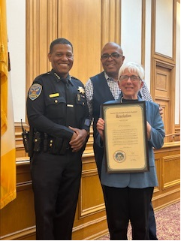

XX. AFFILIATION, DISAFFILIATION OR MERGER OF LABOR ORGANIZATIONS

The Civil Service Commission certifies employee organizations when they affiliate, disaffiliate, or merge with other employee organizations. An affiliation is the formal joining or association of an employee organization with another organization. The employee organization remains a legal entity, but its name may change. A disaffiliation is when two (2) employee organizations agree to no longer affiliate. A merger occurs when two (2) or more employee organizations become a single new legal entity. The absorbed union(s) loses recognition for all its recognized bargaining units as recognition is transferred to the newly merged organization.

Concurrent election to un-represent and elect a new employee organization on the same petition. Formal recognition of an employee organization entitles it to rights and responsibilities as specified in the ERO. Validity requires a 30% show of interest from all employees in the affected bargaining unit.

State labor law (AB 1281) enacted on October 13, 2001, streamlined recognition procedures for public agencies by allowing a signed petition, authorization cards, or union membership cards demonstrating that a majority of the employees in an appropriate bargaining unit desire the representation unless another labor organization has previously been lawfully recognized as the representative. Disputes, in these cases, are remedied in accordance with the procedures outlined in Government Code Section 3507.1.

Affiliation, Disaffiliation or Merger of Labor Organizations
The Civil Service Commission certifies employee organizations when they affiliate, disaffiliate, or merge with other employee organizations. An affiliation is the formal joining or association of an employee organization with another organization. The employee organization remains a legal entity, but its name may change. A disaffiliation is when two (2) employee organizations agree to no longer affiliate. A merger occurs when two (2) or more employee organizations become a single new legal entity. The absorbed union(s) loses recognition for all its recognized bargaining units as recognition is transferred to the newly merged organization.

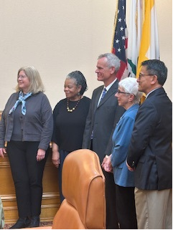

In Appreciation

Over the course of carrying out our duties, the members and staff of the Civil Service Commission interact with a wide range of people both in and outside of City government. The Commission works closely with the Chief of Staff, other elected officials, employee organizations, departmental management and staff, and community leaders and groups. These working relationships contribute a great deal to the Commission’s oversight of the merit system and decision-making authority is the interest of San Francisco residents. We would like to express our sincere appreciation to all of those who work to support merit system employment in San Francisco. Thank you!

