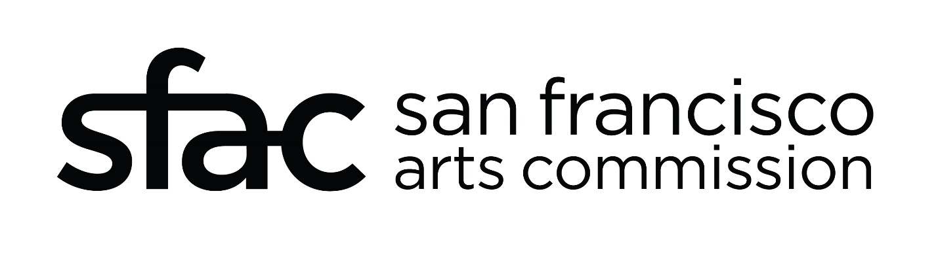

CIVIC CENTER PLAZA TEMPORARY SCULPTURE INSTALLATION
PUBLIC ART PROJECT PLAN

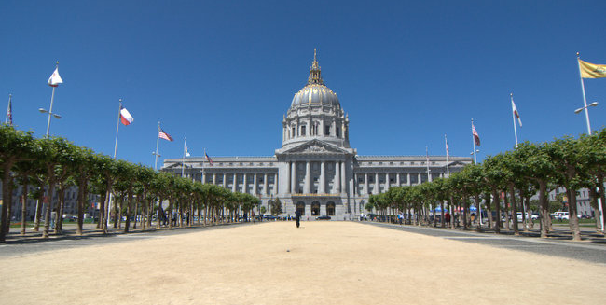

BACKGROUND
San Francisco’s Civic Center Plaza is a prominent public space defined by its grand scale, classical architecture, and central location in the heart of the City. Bordered by key civic and cultural landmarks—including City Hall, the Bill Graham Civic Auditorium, and the Superior and Supreme Courts of California—the plaza reflects the City’s historical and governmental legacy. Designated as a National Historic Landmark, the plaza offers a unique blend of formality and openness, serving as both a gathering place for major public events and a daily commons for workers, commuters, and residents. Its accessibility is enhanced by nearby BART and MUNI stations and an underground parking structure, making it a vital, active part of San Francisco’s urban fabric.
As part of Shaping Legacy—a Mellon Foundation–funded initiative to critically examine and reimagine San Francisco’s monuments and memorials—the San Francisco Arts Commission (SFAC) is seeking to borrow an existing sculpture, or series of sculptures, for temporary installation in Civic Center Plaza. Scheduled for Spring 2026, the one-year loan will spotlight work by a single artist or artist team whose practice engages with core themes identified by Shaping Legacy: repair and reckoning with historical harm; representation, power, and equity in public commemoration; and the complexity of untold or underrepresented histories. SFAC invites submissions of fully realized, installation-ready sculpture that embodies inclusive narratives, encourages meaningful community engagement, and enriches the collective understanding of public memory and civic identity.

ART OPPORTUNITIES
- A freestanding sculpture (or series of sculptures) of prominent scale for temporary display in San Francisco’s Civic Center Plaza, in front of City Hall.
  - The sculpture will be on view for a period of approximately six months to one year, with the final exhibition dates established in consultation with SFAC and the artwork lender.
  - Sculpture foundations that require below-grade installation or drilling into the plaza surface are not permitted. Acceptable alternatives may include mounting the sculpture on a steel plate or on a freestanding pedestal that uses weighted ballasts for stability.

PROJECT GOALS
The goals of this project align with the principles of Shaping Legacy, supporting a critical and creative exploration of how public monuments and memorials can reflect a more inclusive and representative civic narrative. Specifically, selected artwork should:
- Foster inclusive narratives, invite community dialogue, and contribute to an expanded understanding of public memory and civic belonging.
- Be of a prominent scale that responds to the architectural and spatial context of Civic Center Plaza, ensuring strong visual presence within this historically significant civic space.
- Be constructed from durable, low-maintenance materials suitable for outdoor display and safe for public interaction.

ARTWORK BUDGET
Project costs—including artwork packing, roundtrip transportation, insurance, engineering, installation, deinstallation, and maintenance for the duration of the display—will be determined based on the specific requirements of the selected artwork.
ARTIST RECRUITMENT APPROACH AND ELIGIBILITY
Arts Commission staff will issue a Request for Proposals (RFP), open to professional, practicing artists who either reside in the United States or are represented by a U.S.-based gallery. Outreach and recruitment will focus on available artworks that align to the specific goals of the project.
ARTWORK SELECTION PROCESS
Eligible applications will be reviewed by SFAC staff, who will identify and recommend a sculpture for the site in consultation with the Mayor’s Office, the San Francisco Recreation and Parks Department, and the Civic Center Community Benefit District. Applications deemed eligible may also be considered for placement at other sites or for future public art opportunities.
TIMELINE (Subject to change)
Project Plan Approval (VAC) August 20, 2025
RFP Issued September 2025
RFP Deadline November 2025
Review of Proposals December 2025
VAC Approval January 2026
Arts Commission Approval February 2026
Artwork Loan Agreement Complete April 2026
Artwork Installation Summer 2026

FURTHER INFORMATION
Contact Jackie von Treskow, Senior Public Art Program Manager, at (415) 819-1055 or jackie.vontreskow@sfgov.org.

