BHS CANS/ANSA Certification Instructions

All providers completing ANSA or CANS assessments for AOA and CYF members must be certified to use these tools. Certification must be obtained within 30 days of being hired by a program and reviewed annually.

Providers may choose to complete certification training for specific tools they use (e.g. ANSA, CANS 0-5, or CANS 6-20). However, certification on any one instrument qualifies the provider to use all instruments. For example, completing ANSA certification also certifies you to use CANS, and vice versa.

Recertification timelines vary by user and are based on the date of your last certification. For instance, if you were certified on 7/12/2025, your next certification is due on 07/12/2026, and so on.

The TCOM website will send reminder emails:
- 30 days before your certification expires
- 7 days before
- 1 day before
- and 7 days after expiration

Please complete recertification as soon as possible. If you do not have a valid certificate within 90 days after expiration, your account will be deactivated.

For newly hired AOA providers, initial training will be conducted virtually by TCOM-certified DPH trainers. This training is mandatory. AOA training courses are held monthly and typically last about 4 hours, usually split across two consecutive days. The exact schedule is determined by the AOA training team and communicated regularly.

After completing the initial training, providers must take a certification exam on the TCOM training Website. Providers are required to recertify every 12 months, which can also be completed through the same website.

CANS training is delivered virtually through the TCOM website course. Instructions for accessing the training begin on page 3.

Important: Please use one of the following compatible web browsers when completing certification:

- Google Chrome
- Firefox
- Safari
- Microsoft Edge

To register for an account or to obtain your ANSA/CANS Certification (approx. 3-4 hours), follow the Registration and/or Certification directions below.

To update your account settings, view the Managing Your Account directions at the end of the document.

To retrieve a forgotten password or to reactivate your account visit Retrieving Your Password or Reactivating Your Account for information.

Registration and/or Certification:

- Register for an account or log into your existing account.

  - If this is the first time you are getting certified for the CANS/ANSA in San Francisco: register for an account here https://www.schoox.com/academy/CANSAcademy/register Sign Up - The most elegant online learning and training platform (schoox.com). Note: If you were already registered at the old canstraining.com website, skip to step b. below.

    - Enter your information.

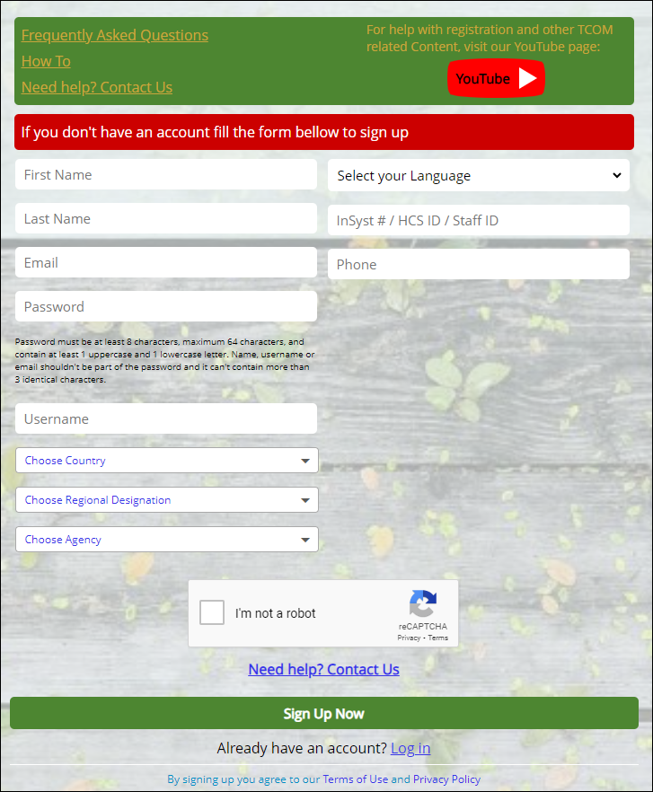
      - For Country, select United States of America. For Regional Designation, select California.
      - In the Choose Agency field, there several agencies listed after filtering for Country and Regional Designation. As a result, only a partial list of agencies to select from is visible in the drop down menu.

        - If you know the name of your agency, type it in the search bar within the Choose Agency field. Agency names will auto-populate. Locate and select your agency.

        - If you cannot locate your agency name, type “San Francisco County” in the search bar. The field will auto-populate with all programs associated with San Francisco County.

        - View Appendix A for a list of current San Francisco County agencies available for selection.

      - In the License # / HCS ID / Staff ID field, enter your EPIC User Number. This will allow Quality Management to match your Schoox (TCOM training) account to your provider’s information in EPIC.

      - View Instructions for finding Staff ID

    - Remember to record your username and password, as it will be needed for recertification in the following years.

    - Select the I’m not a robot box (unless you are a robot)

    - Click Sign Up Now. Skip to step 2) of these directions to continue.

  - Existing users: Users who previously had an account at the old canstraining.com website will use this link to log in Login - The most elegant online learning and training platform (schoox.com)
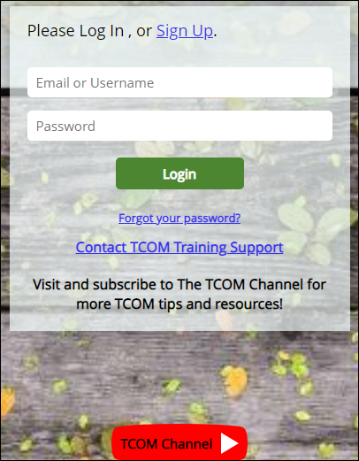

    - If you are an existing user logging onto the Schoox platform for the first time, enter the following:

- For Email or Username, enter the email address used on the previous platform Learner Nation.

- For password, enter the word “password”.
  - Do enter the password used with your Learner Nation account.
  - Do not select Forget Password and enter the temporary password sent to you.

- Select green “Login” button.

- You will be asked to create a temporary password. Though it states temporary, you may keep it as your permanent password. You will not be prompted to create another one at a later time.

- You will be asked to select your agency. For helpful tips selecting agency, see step b) above.

If you are an existing user who has logged onto the Schoox platform at least once, enter your email/username and password. Select the green “Login” button.

- Congratulations! You are now logged into your account. Hover your curser over Training on the top of the page and select Courses.

  - If you do not see a list of available training courses, you will need to purchase a course bundle first.

    - Hover over Training and select Bundles.

    - Select California, Behavioral Health- San Francisco County

    - Click on Purchased (it’s free)

    - All CANS and ANSA training courses will load to your Course Catalogue list in the Courses section.

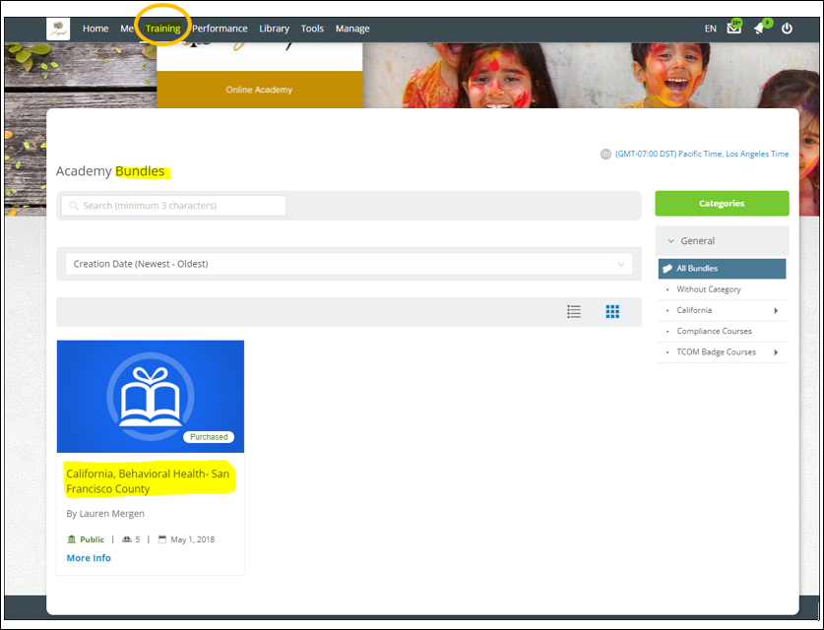

- Select the training course link you need to complete from the Course Catalogue list to be redirected.

  - You do not have to complete the training in one sitting. Feel free to stop and resume at a later time. Your work automatically saves. The only exception is the final step of the training, the final vignette exam. Once you enter this step, you have two hours to complete it.

  - You are not required to complete all steps for certification, only the final vignette exam. However, it is strongly recommended that new users review all training content prior to taking the final exam.

- Prior to starting the training, select the Supplemental Materials icon on the course toolbar to download the Manual and supporting documents. You may find it helpful to reference the material throughout the training.

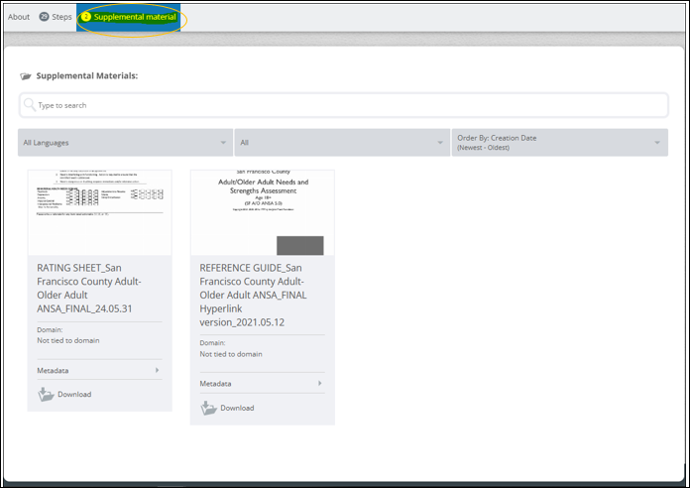
- Select the Steps icon from the same toolbar to access the course training. To begin the training, click on Step 1.

- Once you have completed a step, exit the window. The step icon will indicate “Completed!” and turn green. You may move on to the following step. Continue this process until the end of the training. Note that you do not have to complete the steps in order.
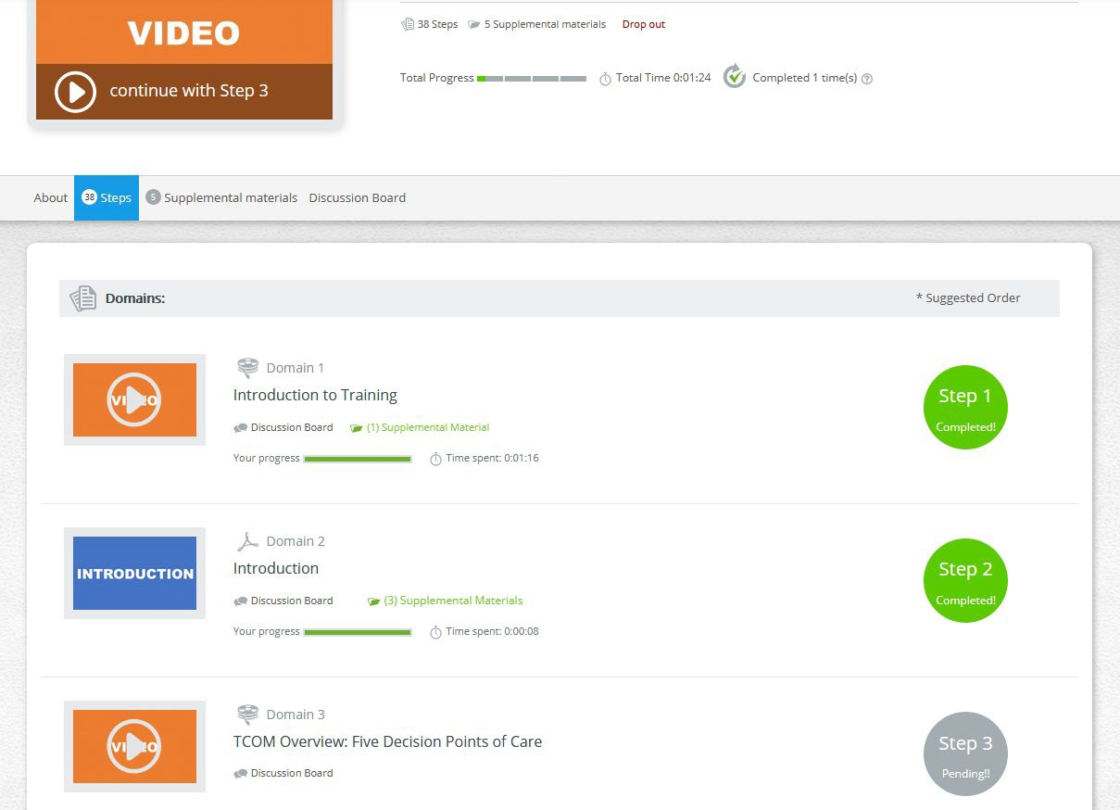
- For those who are re-certifying, all or some of the training step icons will already appear with “Completed!” in green. They will permanently remain this way regardless if your certification has expired or not.
  - Select any step you would like to review.
  - For the final vignette exam module, select the blue “Retake Vignette” button.

- For quiz modules, you will be redirected to the Review page after submitting all your answers. Select any question you answered incorrectly to review the suggested rating. For example, in the screenshot below, I chose a "3" for Adjustment to Trauma, which is flagged as incorrect.
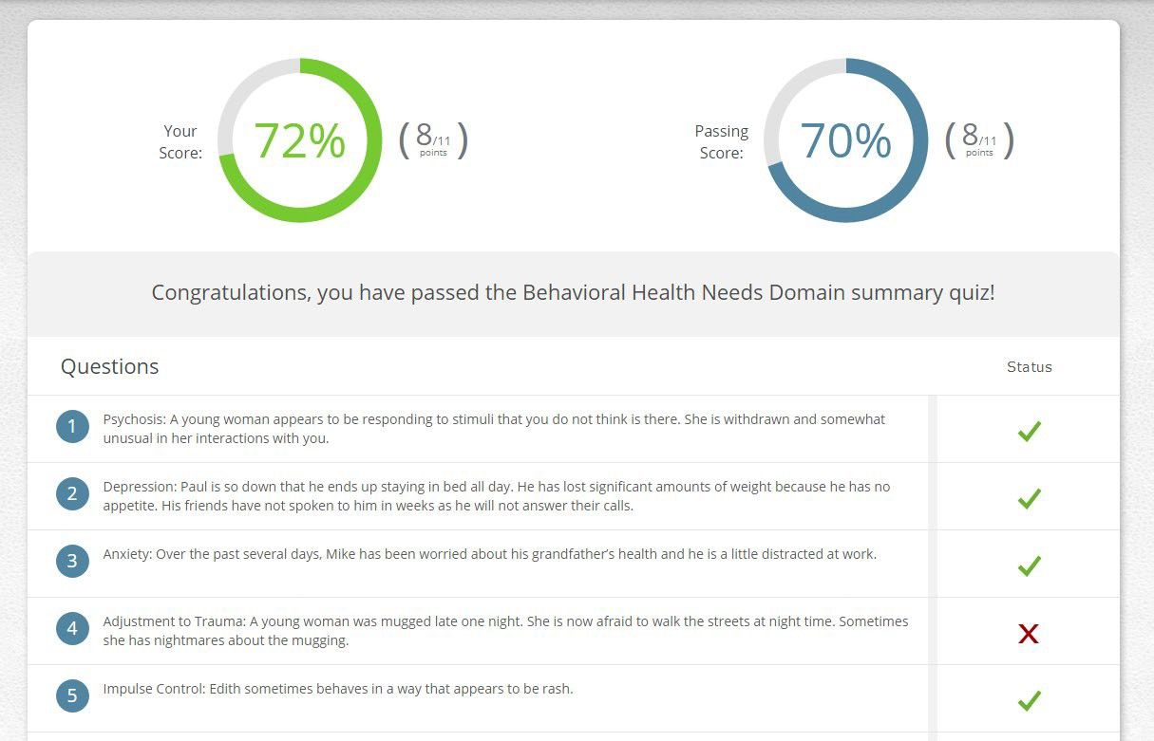

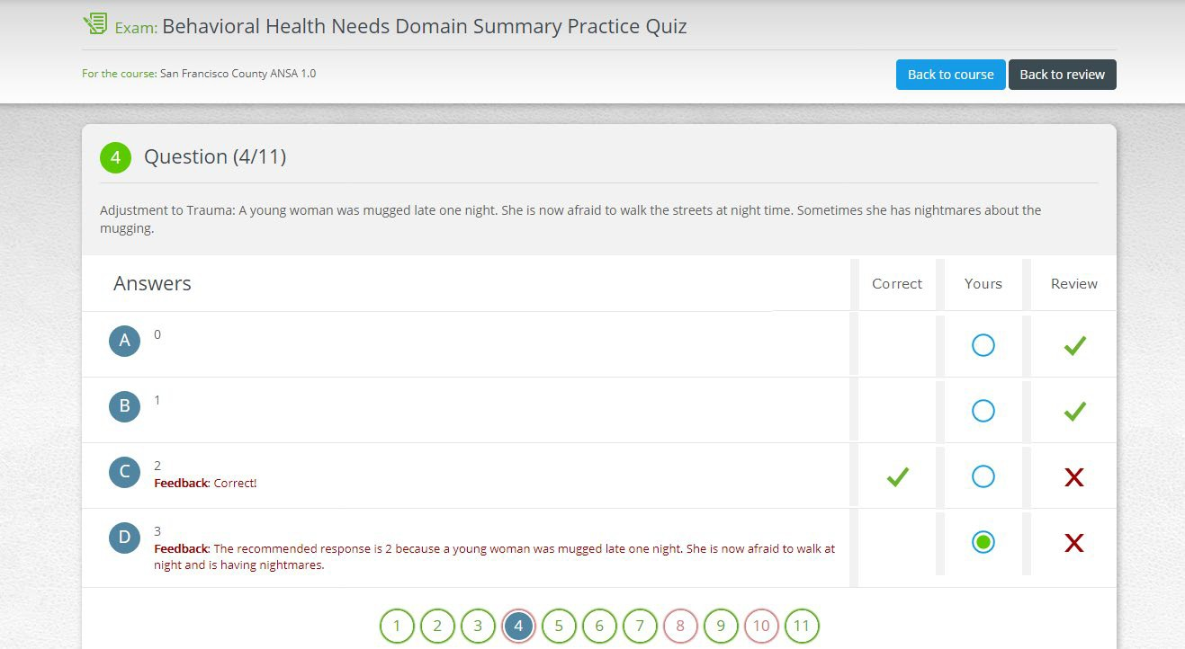
When I click on it, I get the explanation below.

  - You may review additional questions by selecting the corresponding numbers at the bottom of the screen.

  - Select the black “Back to review” button, then the blue “Retake Exam” button to retake the quiz or select the blue “Back to course” button to resume the training.

- The second to the last step of the training is the Practice Vignette step.

  - Completing a practice vignette, though optional, is recommended in preparation for the final vignette exam.

  - There is no limit to the number of practice vignettes you take.

  - This is the only step that you are not required to view, complete or pass for certification.

- The last step of the training is the final vignette exam.

  - You must complete and pass this step for certification.

  - You have an unlimited number of attempts available to pass the final vignette.

  - Read Vignette Assumption, then select the blue “Start Vignette” button in the center of the page. For those re- certifying, you will see a blue “Retake Vignette” button instead.

  - Once you enter this step, you have 2 hours to complete it.

  - You can navigate through all sections of the final exam by using the green “Previous Section” or “Next Section” buttons at the top right corner. Don’t forget to hit the blue “Finish” button to officially submit your exam.

  - A passing score means obtaining a coefficient of .70 or higher. Thus, when testing you will not lose a lot of credit for being 1 point off here and there but you will lose a lot of credit for being consistently 2 or 3 points off.

  - After you become certified, keep a copy of the certificate for your records. Give a copy to your supervisor depending on department policies.

Managing Your Account

- A month before your certification expires, the website will send you a reminder email. It is important to keep your information up to date in the system.

  - To edit account:

    - Hover your curser over Me on the top of the page and select My Settings.

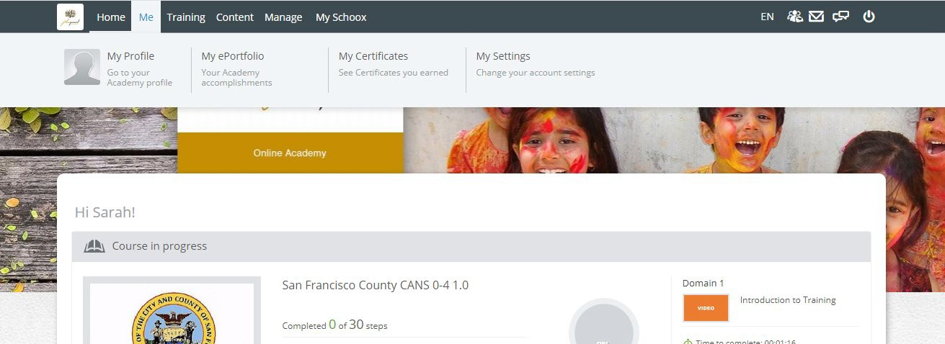

    - Select My Account on the left side of the page

    - You have the option to update your email address or change your account password.

- To view current and past certificates:

  - Hover your curser over Me on the top of the page and select My Certificates.

Retrieving Your Password or Reactivating Your Account

- Should you forget your password, do not create a new account.

  - Instead click “Forgot Your Password?” on the login page and the site will email you a reset password.

  - It should take about a minute for the site to email you a reset password. Follow instructions provided in the email.

- If you have not recertified within 90 days of your certification expiration date, your account will be deactivated. You will need to contact the site to have it reactivated because you will not be able to create a new account under the same email address.

  - Email BHS-SF Administrator at winifred.chow@sfdph.org for assistance.
  - You may email the TCOM support site for reactivation at support@TCOMTraining.com.
  - Please give the site at least 24 hours to respond.

Appendix A

San Francisco County Agencies

Note: some agencies are misspelled – we are working with the website to correct these.
- Choose Agency

- 1380-Admin - San Francisco County
- A Better Way - San Francisco County
- A Woman's Place - San Francisco County
- AARS - San Francisco County
- AIIM Higher - San Francisco County
- Alternative Family Services - San Francisco County
- Asian American Recovery Services - San Francisco County
- Baker Places - San Francisco County
- Bay Area Addiction Research and Treatment - San Francisco County
- Bay Area Training Academy Services - San Francisco County
- Bayview Hunters Point MH - San Francisco County
- Bayview YMCA Family Resource Center-San Francisco County
- Behavioral Health Access Center - San Francisco County
- Boys and Girls Club - San Francisco County
- Castro Mission Health Center - San Francisco County
- Catholic Charities SF Boys Home- San Francisco
- Center on Juvenile and Criminal Justice - San Francisco County
- Central City Older Adults - San Francisco County
- Child Crisis - San Francisco County
- Chinatown Child Development Center - San Francisco County
- Chinatown North Beach MH - San Francisco County
- Citywide Case Management & Community Focus - San Francisco County
- Community Housing Partnership - San Francisco County
- Community Works West - San Francisco/Alameda County
- Community Youth Center - San Francisco County
- Conard House - San Francisco County
- Crisis Response Services - San Francisco County
- Curry Senior Center - San Francisco County
- Department of Public Health - San Francisco County
- Edgewood - San Francisco County
- Epiphany - San Francisco County
- Episcopal Community Services - San Francisco County
- Family Builders - San Francisco County
- Family Mosaic Project - San Francisco County
- Family Service Agency - San Francisco County
- Felton Institute FSA - San Francisco County
- FMP-Bayview - San Francisco County
- Foster Care Mental Health - San Francisco County
- Fred Finch - San Francisco County
- FSA-Full Circle - San Francisco County
- HAFCI - San Francisco County
- Health right 360 - San Francisco County
- Homeless Children's Network - San Francisco County
- Homeless Prenatal - San Francisco County
- Huckleberry - San Francisco County
- Hyde St. - San Francisco County
- Infant Parent Program - San Francisco County
- Instituto Familiar de la Raza - San Francisco County
- Jewish Family Children's Services - San Francisco County
- LHH Dept. of Psychiatry - San Francisco County
- McAuley - San Francisco County
- Mission ACT - San Francisco County
- Mission Family Center - San Francisco County
- Mission Mental Health - San Francisco County
- Native American Health Center - San Francisco County
- Oakes - San Francisco County
- OMI Family Center - San Francisco County
- OTTP - San Francisco County
- Pacific Clinics - San Francisco County
- Progress Foundation - San Francisco County
- RAMS - San Francisco County
- ROYAL - San Francisco County
- S. Van Ness Adult Behavioral Health Services - San Francisco County
- Safe & Sound - San Francisco County
- Safe and Sound- San Francisco County
- SAGE Project - San Francisco County
- San Francisco County Human Services - San Francisco County
- San Francisco Lesbian Bisexual Gay Transgender Community Center - San Francisco County
- San Francisco Unified School District - San Francisco County
- SECFTC - San Francisco County
- Seneca Center - San Francisco County
- Seneca Connections - San Francisco County
- Seneca Potrero - San Francisco County
- SF FIRST - San Francisco County
- SFBGH - San Francisco County
- SFCBH - San Francisco County
- SFGG (EDCM) - San Francisco County
- South of Market MH - San Francisco County
- Southeast Child and Family Therapy Center - San Francisco County
- Southeast Mission Geriatric - San Francisco County
- SPY - San Francisco County
- St. James Infirmary-San Francisco County
- St. Vincent's - San Francisco County
- Stonewall Project - San Francisco County
- Sunset Mental Health Clinic - San Francisco County
- Swords to Plowshares - San Francisco County
- Targeted Case Management - San Francisco County
- Thunder Road - San Francisco County
- Transitional Youth Services - San Francisco County
- UCSF Alliance Project - San Francisco County
- UCSF Center on Deafness - San Francisco County
- UCSF Citywide Forensics - San Francisco County
- UCSF Infant-Parent Program- San Francisco
- UCSF-CAS - San Francisco County
- UCSF-CASARC - San Francisco County
- Unity Care-San Francisco County
- Walden House - San Francisco County
- Westcoast’s Therapeutic-Collaborative Assessment-San Francisco County
- Westside-ACT - San Francisco County
- Westside-Ajani - San Francisco County
- Westside-CalWorks - San Francisco County
- Westside-CS - San Francisco County
- YMCA-Urban Services - San Francisco County
- Youth Service Bureau of The YMCA - San Francisco County

Instructions for finding Staff ID

For CANS/ANSA TCOM Training Registration information
EPIC_ How to look for your EPIC Login information (StaffID) for TCOM registration?

Goals are to get a staff identifier and the correct First and Last name for TCOM registration fields-InSyst#/HCSID/StaffID & First and Last name.
- Login to the EPIC system.
- Select or search for “Record Viewer.”
- On the INI filed- enter “EMP.”
- On the Record field- enter First & Last name
- Select “View Record.”
- Abstract your User Number (#1)-a 4-digit number (e.g. 1534) and System Login (#45)- First (e.g. John) and Last Name (e.g. Smith) for TCOM Registration.

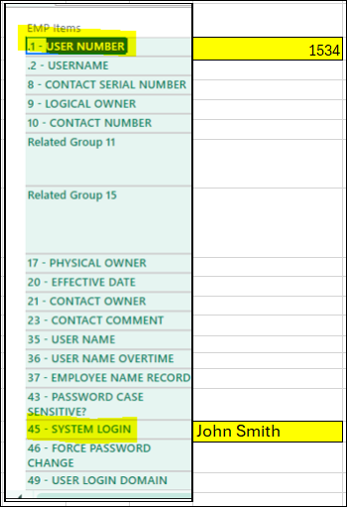

- Enter your EPIC User Number as your InSyst#/HCS ID/Staff ID when you register for TCOM Training.
- Use your EPIC System Login name as your First & Last name when registering for TCOM Training.

TCOM Registration website
Sign Up - The most elegant online learning and training platform (schoox.com)

