
Elections Commission

City and County of San Francisco

Michelle Parker, President John Arntz, Director of Elections Renita LiVolsi, Vice President
Rebecca Bers Marisa Davis, Commission Secretary
Neil Hallinan Trevor McNeil
Dena Aslanian-Williams

REGULAR MEETING AGENDA DRAFT
August 19, 2026
6:00 - 9:00 PM
City Hall, Room 408
1 Dr. Carlton B. Goodlett Place San Francisco, California 94102 & Remote via WebEx
The meeting will be held both in person at the location listed above and remotely via WebEx. WebEx details are provided on the following page.
Members of the public may attend the meeting to observe and provide public comment either at the physical meeting location listed above or remotely / online.
Instructions for providing public comment remotely appear on the last page of this agenda.

In addition to participating in real time, interested persons are encouraged to participate in this meeting by submitting public comment in writing by 12:00 p.m. on the day of the meeting to elections.commission@sfgov.org.

1 Dr. Carlton B. Goodlett Place – Room 48, San Francisco, CA 94102-4634
Voice (415) 558-6159 Fax (415) 554-7457; TDD (415) 554-4386; http://sfgov.org/electionscommission

Join link:
https://sfpublic.webex.com/sfpublic/j.php?MTID=me7e4a8896bd6057e166e9d39133b34b9

Webinar number:
2660 990 3156

Webinar password:
MwxnpxPf737 (69967973 when dialing from a video system)

Join by video system Dial 26641321305@sfpublic.webex.com You can also dial 173.243.2.68 and enter your webinar number.
Join by phone +1-415-655-0001 United States Toll (San Francisco) Access code: 2664 132 1305

Order of Business

Call to Order & Roll Call
The San Francisco Elections Commission acknowledges that we are on the unceded ancestral homeland of the Ramaytush Ohlone, who are the original inhabitants of the San Francisco Peninsula. As the indigenous stewards of this land and in accordance with their traditions, the Ramaytush Ohlone have never ceded, lost, nor forgotten their responsibilities as caretakers of this place, as well as for all peoples who reside in their traditional territory. As guests, we recognize that we benefit from living and working on their traditional homeland. We wish to pay our respects by acknowledging the ancestors and relatives of the Ramaytush Community and affirming their sovereign rights as First Peoples.

General Public Comment
Public comment on any issue within the Elections Commission’s general jurisdiction that is not covered by another item on this agenda.

Approval of Previous Meeting Minutes
Discussion and possible action on June 17, 2026 Elections Commission meeting minutes.

Director’s Reports and Communications
Discussion and Possible Action regarding the July and August 2026 Director’s Report.
  - Updates on operations and administrative functions
  - Final election report regarding the May election
  - Department’s outreach to voters

Closed Session -- Personnel Exception

Pursuant to California Government Code Section 54957(b) and San Francisco Administrative Code 67.10(b), the Elections Commission will meet in closed session to review the public employee evaluation of the Director of the Department of Elections.

a. Public comment on all matters pertaining to item 8 including whether to hold item 8 in closed session.

b. Vote on whether to hold Item 8 in Closed Session. (Action)

c. CLOSED SESSION ON EVALUATION OF DIRECTOR OF DEPARTMENT OF ELECTIONS (Discussion and Action).

d. If closed session is held, reconvene in open session.

e. Possible report on any action taken in closed session, as specified in California Government Code Section 54957.1(a) and San Francisco Administrative Code section 67.12(a). (Discussion and Action)

f. Vote on whether to disclose closed session discussion regarding the public employee performance evaluation as specified in San Francisco Administrative Code section 67.12(a). (Discussion and Action)

Discussion of Open Source Voting System

A panel discussion based regarding Open Source Voting as facilitate by President Parker. As many of the commissioners are new to the Election Commission, a review will provide clarity regarding this issue and the discussion will allow for questions or comments.

Commissioners’ Reports
Commission reports will be limited to a brief description of activities from each Commissioner. Commission discussion will be limited to determining whether to calendar any of the issues raised for a future Commission meeting.
  - Commission President's Report
  - Commissioners' Reports
  - Commission announcements and scheduling of items identified for consideration at future Commission meetings (ACTION)

Agenda Items for Future Meetings and Commissioner Announcements
Discussion and possible action regarding items for future agendas.

ADJOURNMENT

Materials contained in the Commission packets for meetings are available for inspection and copying during regular office hours at the Department of Elections, City Hall Room 48. Materials are placed in the Elections Commission's Public Binder no later than 72 hours prior to meetings. Any materials distributed to members of the Elections Commission within 72 hours of the meeting or after the agenda packet has been delivered to the members are available for inspection at the Department of Elections, City Hall Room 48, in the Commission's Public Binder, during normal office hours.

Cell phones, pagers and similar sound-producing electronic devices: The ringing of and use of cell phones, pagers and similar sound-producing electronic devices are prohibited at this meeting. The Chair may order the removal from the meeting room of any person responsible for the ringing or use of a cell phone, pager, or other similar sound-producing electronic devices.
UPDATED NOTICE re ACCESS: Accessibility The meeting room is wheelchair accessible.
Wheelchair-accessible entrances are located on Van Ness Avenue and Grove Street. Please note the wheelchair lift at the Goodlett Place/Polk Street is temporarily not available. After multiple repairs that were followed by additional breakdowns, the wheelchair lift at the Goodlett/Polk entrance is being replaced for improved operation and reliability. We anticipate having a functioning lift after the completion of construction in May 2025. There are elevators and accessible restrooms located on every floor.
Read about accessible transportation to City Hall.

Disability Access: The Commission meeting will be held in Room 408, City Hall, 1 Dr. Carlton B. Goodlett Place, San Francisco, CA. The meeting room is wheelchair accessible. The closest accessible BART station is the Civic Center Station at United Nations Plaza and Market Street. Accessible MUNI lines serving this location are: #42 Downtown Loop, and #71 Haight/Noriega and the F Line to Market and Van Ness and the Metro Stations at Van Ness and Market and at Civic Center. For information about MUNI accessible services call (415) 923-6142. There is accessible curbside parking adjacent to City Hall on Grove Street and Van Ness Avenue and in the vicinity of the Veterans Building at 401 Van Ness Avenue adjacent to Davies Hall and the War Memorial Complex.

To obtain a disability-related modification or accommodation, including auxiliary aids or services, to participate in a meeting, please contact the Department of Elections at least 48 hours before the meeting, except for Monday meetings, for which the deadline is 4:00 p.m. the previous Friday. Late requests will be honored, if possible. Services available on request include the following: American sign language interpreters or the use of a reader during a meeting, a sound enhancement system, and/or alternative formats of the agenda and minutes. Please contact the Department of Elections at (415) 554-4375 or our TDD at (415) 554-4386 to make arrangements for a disability-related modification or accommodation.

Chemical-Based Products: In order to assist the City's efforts to accommodate persons with severe allergies, environmental illnesses, multiple chemical sensitivity or related disabilities, attendees at public meetings are reminded that other attendees may be sensitive to various chemical-based products. Please help the City accommodate these individuals.

KNOW YOUR RIGHTS UNDER THE SUNSHINE ORDINANCE (Chapter 67 of the San Francisco Administrative Code): Government's duty is to serve the public, reaching its decisions in full view of the public. Commissions, boards, councils, and other agencies of the City and County exist to conduct the people's business. This ordinance assures that deliberations are conducted before the people and that City operations are open to the people's review. FOR MORE INFORMATION ON YOUR RIGHTS UNDER THE SUNSHINE ORDINANCE OR TO REPORT A VIOLATION OF THE ORDINANCE,
CONTACT THE SUNSHINE ORDINANCE TASK FORCE: Sunshine Ordinance Task Force; 1 Dr. Carlton B. Goodlett Place; Room 244; San Francisco, CA 94102-4689. Phone: (415) 554-7724; Fax: (415) 554-5163; Email: sotf@sfgov.org;

Website: http://sfgov.org/sunshine. Copies of the Sunshine Ordinance can be obtained from the Clerk of the Sunshine Ordinance Task Force, at the San Francisco Public Library, and on the City's website at http://sfgov.org.

Lobbyist Registration and Reporting Requirements: Individuals that influence or attempt to influence local policy or administrative action may be required by the San Francisco Lobbyist Ordinance (San Francisco Campaign and Governmental Conduct Code sections 2.100 – 2.160) to register and report lobbying activity. For more information about the Lobbyist Ordinance, please contact the San Francisco Ethics Commission at 25 Van Ness Avenue; Suite 220; San Francisco, CA 94102. Phone: (415) 252-3100; Fax: (415) 252-3112; Email: ethics.commission@sfgov.org; Website: http://www.sfethics.org.

Public Comment Instructions for Remote Participants

When calling in by telephone (preferred):
When your item of interest comes up, dial *3 (star button followed by the number 3) on your phone to raise your hand and be added to the public comment line. You will then hear, "You have raised your hand to ask a question." Please wait until the host calls on you.
The line will be silent as you wait your turn to speak. Ensure you are in a quiet location. Before you speak, mute the sound of any equipment around you, including television, radio, or computer. It is especially important that you mute your computer if you are watching via the web link to prevent feedback and echo when you speak.

If you change your mind and wish to withdraw yourself from the public comment line, press
*3 again. You will hear the system say, "You have lowered your hand."

Using your computer web browser (when phone not available)
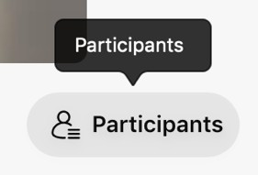
Make sure the "Participants" side panel is showing by clicking the "Participants" button shown in the picture at the right.

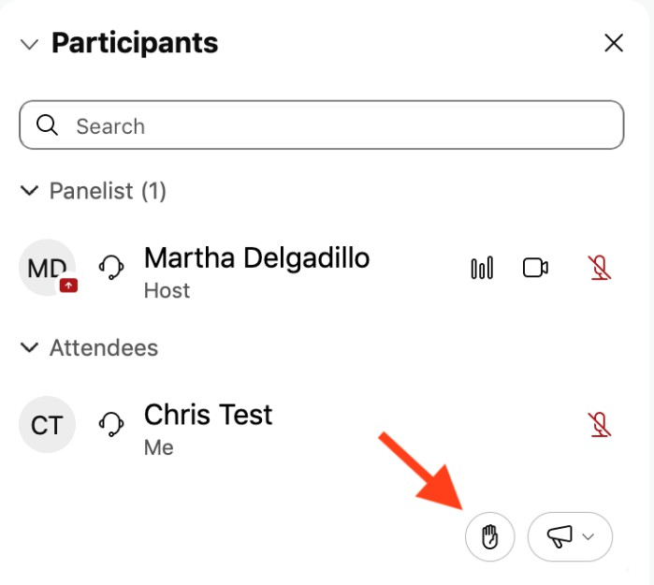
Then, make sure the "Participants" panel is expanded in the side panel by pressing the small arrow indicator in the panel. You should see a list of Panelists, followed by a list of Attendees. At the bottom of the list of Attendees is a small button or icon that looks like a hand (see where the red arrow is pointing in the
picture at the right).

Press the hand icon to raise your hand. The host will unmute you when it is time for you to comment. When you are done with your comment, click the hand icon again to lower your hand.

